
Tertiary Infotech Academy Pte Ltd
UEN: 201200696W
LEARNER GUIDE
For
Claude AI Masterclass
Threads Edition
Course Code: C1382
Conducted by
Tertiary Infotech Academy Pte Ltd
UEN: 201200696W
Version 6.0 · 28 October 2026

DOCUMENT VERSION CONTROL RECORD
Version Number | Effective Date of Release | Summary of Included Changes | Author
1.0 | 15 September 2026 | Initial release. | Dr. Alfred Ang
2.0 | 15 September 2026 | Finance task automation scenarios. | Dr. Alfred Ang
2.1 | 16 September 2026 | Eight finance labs with mock data and skills. | Dr. Alfred Ang
3.0 | 17 September 2026 | Rebuilt on the Claude Style design with three topics and six labs on one fictitious finance firm; prompts added to the slides, Learner Guide and labs. | Dr. Alfred Ang
3.1 | 17 September 2026 | Added an invoice-processing first lab, the context window section, the skill lifecycle and the two About the Trainer slides. | Dr. Alfred Ang
3.2 | 18 September 2026 | Restructured to ten labs: connectors, a built-in skill board deck, two learner-written skills, a Claude Project and a plugin. | Dr. Alfred Ang
4.0 | 18 September 2026 | First stable release of the ten-lab finance course. | Dr. Alfred Ang
4.1 | 18 September 2026 | Lab 4: recovery step for the Google Drive connector's "insufficient scope" error. | Dr. Alfred Ang
4.2 | 18 September 2026 | Moved the Skills vs. Plugins diagram to sit immediately before the plugin lab. | Dr. Alfred Ang
5.0 | 27 October 2026 | Renamed Claude AI Masterclass and rebuilt for marketing teams on the redesigned Claude Projects: one fictitious brand launch (Lumo Kopi Co.) run in a single project across ten labs, with a lead agent and parallel threads, Live Artefacts, Drive and Gmail, Slides and Docs, skills, plugins and mods, social posts, a launch video and scheduled tasks. Lab folders now hold only the prompt PDF and data; full instructions are in the Learner Guide and every prompt is on a copy-ready prompts page. Trainer profile adds the Claude Certified Associate certification. | Dr. Alfred Ang
5.1 | 27 October 2026 | Issued in two editions from one source. The Classic Projects Edition teaches Projects as most accounts show them today — Instructions, Context, Folder and Scheduled panels, with parallel tasks started by the learner and a project memory file — and is the edition distributed to learners. The Threads Edition keeps the redesigned Projects with a lead agent and parallel threads. The prompts page adds a lab index and links the two editions; the AI history slide follows the Agentic AI Applications with Claude Code deck. | Dr. Alfred Ang
5.2 | 27 October 2026 | Topic 1 adds Project vs Session, a diagram of how sessions sit in a project (Classic) or how project, session, thread and agent relate (Threads), A Project Answers Four Questions (Instructions HOW, Context WHAT, Folder WHERE, Scheduled WHEN), Instructions vs Context and the project-room analogy; the pricing slide is updated (Free, Pro, Max, Team and Enterprise) and a Claude models slide added (Haiku, Sonnet, Opus, Fable). Every lab gains an In the project panel. Lab 7 builds a Next Lumo post mod; Lab 8 now schedules the daily post; Lab 10 schedules the weekly report. Timetable rebalanced (Lab 7 25 min, Lab 8 40 min, Lab 10 20 min). Glossary adds Context, Instructions and Session. Seventeen annotated screenshots from the class delivery added to the deck and LG: plan and usage, model and effort menus, permission mode, the project page and + menu, the Gmail connector, installing a skill, and the Lab 3, Lab 4 and Lab 8 outputs. | Dr. Alfred Ang
6.0 | 28 October 2026 | Rebuilt Topic 2 around learner feedback asking for more practical depth on Claude's tools and skills, with direct Claude examples in place of analogies. New slides and LG sections: tools vs skills, Claude's built-in tools, how Claude calls a tool, the Lab 4 tool-call trace, tool permissions, six everyday connector jobs, tool troubleshooting, data analysis with the code tool, the kinds of skill, the lumo-brand-voice SKILL.md, good and bad descriptions, a gallery of workplace skills and skill troubleshooting. Lab 4 adds Drive search and Gmail draft use cases and has Claude list its tool calls; Lab 5 opens with a survey analysis saved to Excel; Lab 6 uses the skill on supplied customer messages, then updates and retests it; Lab 7 opens a plugin's skills. New shared sample data: lumo-customer-messages.txt and the survey in Lab 5. The project-room analogy is replaced by where each part lives in the app. Timetable rebalanced: Topic 2 gains 30 minutes (Topic 1 theory 30 min, Lab 2 35, Topic 2 tools 40 and skills 15, Labs 4-6 35 each; Lab 8 35, Lab 9 25, recap 10). | Dr. Alfred Ang

TABLE OF CONTENTS
Introduction 6
Course Learning Outcomes 6
Before You Start — Preparation 7
Working in a Claude Project 13
The lead agent and its threads 13
The parts of a project 16
Writing the goal 18
Writing project instructions 18
Adding context 19
Working with memory 19
Scheduling tasks 20
Project settings, models and environments 20
Topic 01 — Claude Projects and Market Research 22
The Claude family 22
Lab 1 — Set Up the Lumo Launch Project 22
Market research in parallel threads 26
Lab 2 — Run Market Research in Parallel Threads 26
Live Artefacts 29
Lab 3 — Build the Market Insights Live Artefact 29
Topic 02 — Connectors, Skills and Plugins 34
Tools and skills 34
Connectors and the context window 36
Lab 4 — Connect Google Drive and Gmail 39
Analysing data with Claude 45
Slides, Docs and built-in skills 45
Lab 5 — Analyse the Survey, Then Build the Deck and Brief 46
Agent Skills 50
Lab 6 — Capture the Brand Voice as an Agent Skill 53
Skills, plugins and mods 57
Lab 7 — Add the Marketing Plugin and a Mod 57
Topic 03 — Content Production and Scheduled Work 61
Social content in parallel threads 61
Lab 8 — Create and Schedule Social Posts in Parallel Threads 61
The video pipeline 66
Lab 9 — Produce a 15-Second Launch Video 66
Scheduled tasks 69
Lab 10 — Schedule the Weekly Report and Review the Project 69
Wrap-Up 72
Glossary 73

Introduction
Claude is no longer only a chat window. With the redesigned Claude Projects, you give a project one goal and a lead agent plans the work, splits it into parallel threads and brings the results back to you. This course teaches that way of working through one continuous marketing scenario: you are the marketing team at Lumo Kopi Co., launching a new canned cold-brew kopi. Over ten labs, all inside one project, you research the market in parallel threads, build a Live Artefact dashboard, connect Google Drive and Gmail, produce a launch deck and campaign brief, capture the brand voice as a skill, add a marketing plugin, create two weeks of social posts and a launch video, and schedule the routine work so it runs on its own.
The scenario — The Lumo Cold Kopi launch
The situation: It is late October 2026. Lumo Kopi Co. launches Lumo Cold Kopi, its first ready-to-drink canned kopi, in Singapore on 1 December — six weeks away — and in Kuala Lumpur in January. The marketing team is small, the budget is S$60,000, and nothing has been produced yet: no research, no deck, no posts, no video.
Your role: You are the Lumo marketing team. Instead of juggling a dozen separate chats, you run the whole launch from one Claude Project. Its lead agent plans each job, starts parallel threads for the pieces, and brings the results back for you to check and approve.
Your mission: By the end of the day the project holds everything the launch needs — verified market research, a dashboard, a deck and brief, a brand-voice skill, two weeks of social posts, a launch video — and scheduled tasks that keep it moving while you are away.
Lumo Kopi Co. is a fictitious Singapore coffee brand about to launch Lumo Cold Kopi — a ready-to-drink oat-milk kopi cold brew in a 240 ml can — in Singapore on 1 December 2026 and Kuala Lumpur in January 2027. You are its marketing team. All brands, figures, survey answers and documents in this course are synthetic and used for training only.
This guide carries the full instructions for all 10 labs. Each lab folder in the course repository holds only the lab's prompt PDF and, where the lab needs it, a data folder; the goal, every prompt, the step-by-step instructions and the check step for each lab are here.

Course Learning Outcomes
On completion of this course, you will be able to:
- LO1: Set up a Claude Project with a goal, instructions, context and memory, and explain how its lead agent splits work into parallel threads.
- LO2: Run multi-subject market research as parallel threads and consolidate it into one verified research brief.
- LO3: Build, refine, save and download a Live Artefact dashboard from supplied research data.
- LO4: Connect Google Drive and Gmail and use their tools to reconcile, search, save and draft, sending only what you approve.
- LO5: Analyse survey data with Claude's code tool and Excel, and produce a launch deck and campaign brief with Slides and Docs using built-in skills.
- LO6: Capture a brand voice as an Agent Skill with /skill-creator, use and update it on workplace messages, and install and use a marketing plugin.
- LO7: Create a two-week, multi-platform set of social media posts in parallel threads using the brand-voice skill.
- LO8: Produce a short vertical launch video from a script, storyboard and supplied brand assets.
- LO9: Schedule recurring project tasks, maintain project memory and review thread usage, keeping a human approval step.

Before You Start — Preparation
What you need
- A laptop (Mac or Windows) with the Claude desktop app installed from claude.ai/download.
- A Claude account on a paid plan (Pro or Max) — Projects, Cowork and Live Artefacts are paid-plan features.
- A Google account with Google Drive and Gmail, used for the connector labs.
- The course labs downloaded from https://github.com/tertiarycourses/C1382-Claude-AI-Masterclass — each lab folder holds a prompt PDF and, where needed, a data folder.
- The prompts page open in a browser, so you can copy each prompt with one click: https://tertiarycourses.github.io/C1382-Claude-AI-Masterclass/prompts/threads/
Claude plans
Free lets you try Claude; Cowork, scheduled tasks and full Projects need Pro or Max.
Plan | Price and what it adds
Free | $0. Chat, Slides, Docs, connectors and skills, up to five projects. Sonnet and Haiku.
Pro | $17/mo billed annually · $20 monthly. Cowork, scheduled tasks, the new Projects (beta), Opus.
Max | From $100/mo — 5× or 20× Pro's usage, priority at busy times, $100–$200/mo API credits.
Team · Enterprise | Team $20/seat annual ($25 monthly), premium seats $100. Enterprise $20/seat + usage.

Usage resets every five hours, with weekly limits on paid plans. US$ prices as of 27 October 2026 — verify at claude.com/pricing.
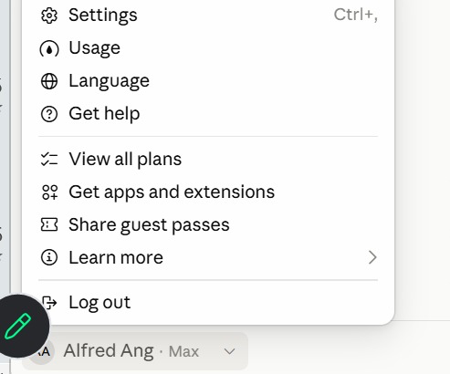
Figure 1 — Check Your Plan and Usage. Click your name at the bottom of the sidebar — the plan shows beside it (here, Max).
1. Usage — How much of your five-hour and weekly limits you have used.
2. View all plans — Compare Free, Pro, Max, Team and Enterprise, and upgrade.
3. Settings — Your profile, connectors and capabilities. Shortcut: Ctrl + comma.
Claude models
Four families, smallest to most capable; all read up to 1M tokens. API prices are US$ per million tokens, input · output.
Model | What it is | Use it for | API price | On plans
Haiku 5.5 | Fastest, most cost-efficient | Quick, high-volume jobs: tagging, short replies | $0.10 / $0.50 | All plans
Sonnet 5.5 | High performance for coding and agents | Everyday drafting, research and analysis | $2 / $10 | All plans
Opus 5.5 | Daily driver for agentic and enterprise work | Multi-step projects, parallel work, careful reviews | $4 / $20 | Pro and above
Fable 5.1 | Most capable, for long-running agents | The hardest, longest jobs | $10 / $50 | Max; Pro via usage credits

Pick the model from the model menu. Bigger models think harder and use more of your plan — save Fable for the jobs that need it.
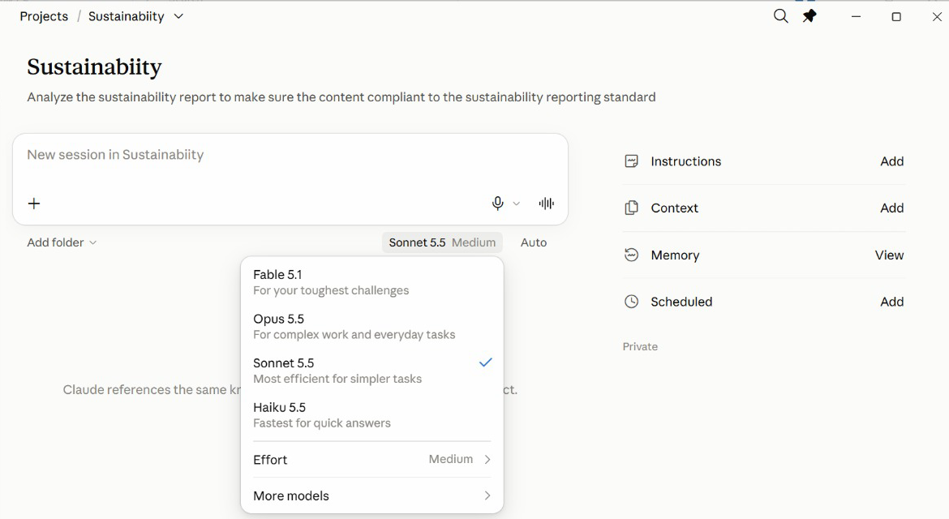
Figure 2 — Pick a Model in the App. The model menu sits under the message box of every new session.
1. Fable 5.1 — For your toughest challenges — uses the most of your plan.
2. Opus 5.5 — Complex work and everyday tasks.
3. Sonnet 5.5 — Efficient for most jobs — a sensible default.
4. Haiku 5.5 — Fastest, for quick answers.
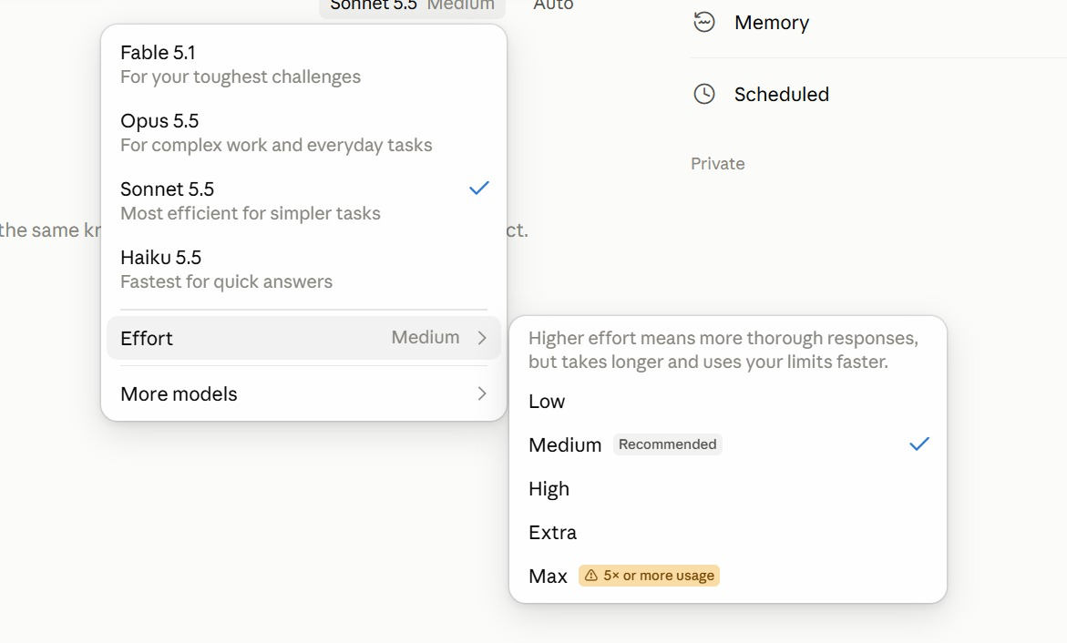
Figure 3 — Effort: How Hard Claude Thinks. Model menu → Effort. Medium is recommended for most work.
1. Low · Medium — Quick, everyday work. Medium is the recommended default.
2. High · Extra — Harder problems: more thorough, but slower and uses your limits faster.
3. Max — Five times or more the usage — save it for the hardest job.
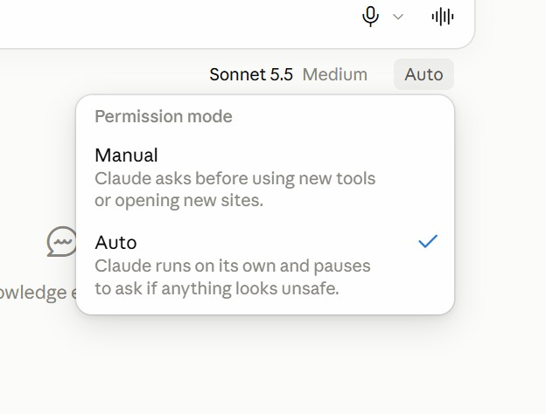
Figure 4 — Permission Mode: Manual or Auto. The menu beside the model sets how freely Claude acts in a session.
1. Manual — Claude asks before it uses a new tool or opens a new site.
2. Auto — Claude runs on its own and pauses to ask only if something looks unsafe.
3. Which to use — Manual while you learn a new connector; Auto once you trust the job.
Verify your setup
Open the Claude desktop app, sign in, and open Projects from the sidebar. If you can see the New project button, your account has the new Projects. If you cannot, the beta has not reached your account yet: run each lab in Cowork mode instead, and attach the lab's data files yourself — every prompt still works.
Course links
Resource | Address
Course repository (lab files) | https://github.com/tertiarycourses/C1382-Claude-AI-Masterclass
Copy-ready prompts page | https://tertiarycourses.github.io/C1382-Claude-AI-Masterclass/prompts/threads/

Conventions used in every lab
- Prompts shown in a bordered box are copied into Claude exactly as they are — or copy them from the prompts page.
- Placeholders such as <YOUR EMAIL> are replaced with your own values.
- All Lumo Kopi data is synthetic; use only the supplied mock data.
- Every lab ends with a check step — confirm the output before moving on.
Rules for every lab
- Work from mock data — Use the supplied synthetic Lumo data — never real customer records in training.
- Scope the connector — Give Claude one Drive folder for the task, not your entire Drive.
- Check every figure — Read the artefact's and the brief's numbers back against the source file.
- Approve before sending — Read each drafted email and post in full; approve it only when the facts match.
- Use a test recipient — Send class exercises to yourself, never to a real customer.
- Watch thread usage — Parallel threads multiply usage — check Project settings → Usage.
Note: Use only the supplied mock data and your own test accounts. Never put real customer, personal or confidential data into a training exercise, and send lab emails to yourself rather than to a real recipient.

Working in a Claude Project
Every lab in this course runs inside one Claude Project — Lumo Cold Kopi Launch — which you create in Lab 1. This chapter explains how a project works and how to set up each of its parts. Come back to it whenever a lab asks you to change the goal, instructions, context, memory or a scheduled task.

The lead agent and its threads
One goal, one lead agent, many threads. You talk to the lead agent. It decides how many threads a job needs, gives each a focused brief, and brings one merged answer back to you.
- Lead agent — Plans, splits and merges
- Thread 1 — Competitors
- Thread 2 — Customer survey
- Thread 3 — Pricing
- Thread 4 — Social trends
- Memory — Shared by every thread
How this changes the way you work:
Before — one chat per job | Now — a Project with a lead agent
A chat for copy, one for visuals, one for competitors. | You state the goal once, to the lead agent.
Re-explain the brand in every new chat. | It splits the work and starts parallel threads.
Copy and paste results between chats yourself. | Each thread reports back; the lead merges the results.
Nothing happens while your laptop is closed. | Goal, memory and context persist across every thread.
You are the project manager. | It only comes back to you when it needs a decision.

Projects and sessions
The project keeps the setup; a session does one piece of work inside it. A session is one conversation with Claude; a project is the workspace that holds many of them and loads the same set-up into each.
A session — one piece of work | A project — the whole goal
One conversation with Claude: a chat, or a thread the lead agent starts. | A lasting workspace that holds many sessions.
Has its own context window, which fills up as you work. | Its goal, instructions, context and memory load into every session.
Ends when the job is done; the next session starts blank. | Stays until you delete it — for weeks or months.
Remembers only what was said inside it. | What one session learns, the next can use, through memory.
Lumo: “Draft the Instagram launch post.” | Lumo: “Lumo Cold Kopi Launch.”

Project, Session, Thread and Agent
- Project — The workspace for one goal. Its goal, instructions, context and memory are shared by every session in it.
- Session — One conversation with Claude, with its own context window.
- Lead agent — The agent you talk to in your session. It plans the job, starts threads and merges their results.
- Thread — A session the lead agent starts for one piece of the job, run by its own agent.
- Agent — The Claude doing the work in a session — the lead agent, or a thread's agent.
Each thread has its own agent and context window. The lead agent merges what they return into one answer for you.
Four questions a project answers
Set these up once and every session in the project starts from them.
Part | Answers | What it means
Instructions | HOW | How Claude must work: brand voice, prices in S$, ask before sending — rules every session follows.
Context | WHAT | What Claude needs to know: brand guidelines, product sheet, launch brief — read, never edited.
Folder | WHERE | Where Claude works and saves: the project files on your computer, or a cloud environment.
Scheduled | WHEN | When work runs without you: Monday 9am the week's post drafts, Friday the weekly report.

The goal says WHY; memory keeps what each session learns for the next.
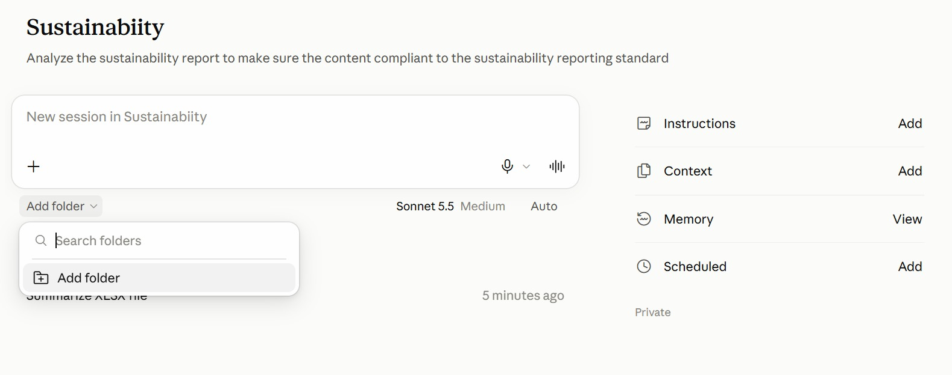
Figure 5 — The Project Page in the App. A project from the class: the goal under its name, the project's panels on the right.
1. Instructions · Context — HOW and WHAT — click Add to write the rules or attach reference files.
2. Add folder — WHERE — under the message box, pick the folder Claude reads from and saves to.
3. Memory · Scheduled — What Claude has learned about the project, and WHEN tasks run on their own.
4. New session — Type in the box to start a session; earlier sessions are listed beneath it.
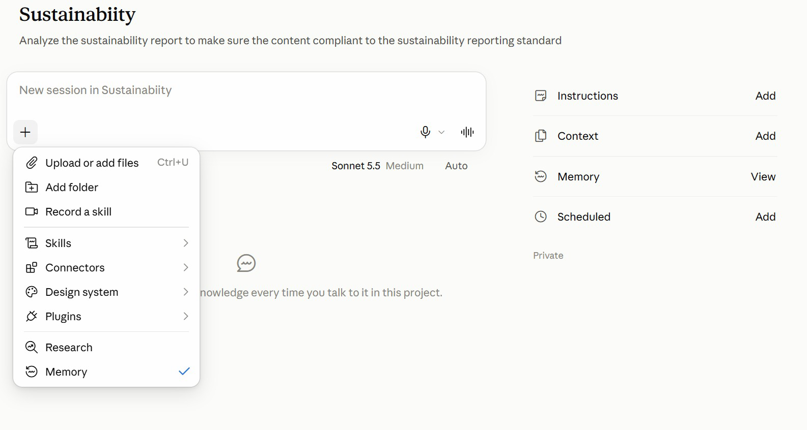
Figure 6 — The + Menu: What a Session Can Use. Click + in the message box to bring files and tools into the session.
1. Files and folders — Upload a file, or add a folder, for this session.
2. Skills · Connectors · Plugins — Choose what the session may use — the brand-voice skill, Gmail, a plugin.
3. Record a skill — Capture a routine you show Claude as a new skill.
4. Research · Memory — Deeper web research; the tick shows the session uses project memory.
When to use a project
Use a project for | Why
A long-running goal | Work keeps arriving for weeks — a product launch, a channel, an app.
A job that splits | One big job breaks into pieces that can run at once — assets, ads, competitors, email.
Lots of research | Many subjects to look into — one thread per competitor, market or segment.
Regular check-ins | You want to review each workstream's progress, not one long chat.

A one-off question that is done in one reply? Use an ordinary chat.

The parts of a project
Part | What it is
Goal | What the project must achieve. The lead agent steers every decision toward it.
Instructions | Standing rules you write: brand voice, currency, never publish without approval.
Context | What Claude reads: files, folders, a Google Drive folder or a GitHub repository.
Memory | What the project learns and keeps between threads. Open the memory files to edit them.
Threads | The parallel workers the lead agent starts for each piece of a job.
Scheduled | Tasks that run on a timetable inside the project — the daily post, the weekly report.

Creating a project
1. Name — What you are working on — Lumo Cold Kopi Launch. This is how you find it in the sidebar.
2. Goal — What the project must achieve, in two or three sentences. You can type it or dictate it.
3. Context — Add the brand kit files now, or a folder or Drive folder. You can skip and add them later.
4. Create project — The lead agent opens, reads the goal and context, and is ready for its first job.
New project is at the top right of the Projects page. Instructions and memory are edited afterwards, in Project settings.
Instructions or context?
Quick test: a sentence that starts Always, Never or Write in… is an instruction. A document is context.
Instructions — how to behave | Context — what to know
Short standing rules you write yourself. | Reference material Claude reads but never edits.
Followed by every session in the project. | Files, a folder, a Google Drive folder or a GitHub repository.
If an output breaks a rule, fix the instruction here. | If a fact in an output is wrong, fix or replace the file.
Keep them short: they are loaded into every session. | Add it once; you never re-attach it again.
Lumo: “Prices in S$. No health claims. Ask before sending.” | Lumo: brand guidelines, product sheet, launch brief.

Instructions, context and memory compared
These three are easy to confuse, and the difference matters: when an output is wrong, it tells you which one to fix.
 | Instructions | Context | Memory
Who writes it | You | You add it | The project, as it works
What it holds | Rules and style | Files and folders to read | Facts and decisions learned
Lumo example | Prices in S$; no health claims | Brand guidelines, launch brief | Launch date moved; IG performs best
Edit it in | Settings → Memory | Context panel | Settings → Memory → memory files
When output is wrong | Tighten the rule | Add the missing file | Correct or delete the fact

Where each part lives in Claude
Every part of a project, where you click to find it, and the Lumo example.
Part | Where you find it in Claude | What it does | Lumo example
Project | Projects in the sidebar → the project | Stays set up for weeks | Lumo Cold Kopi Launch
Session | A new conversation inside the project | Starts fresh; the setup still applies | Draft the Instagram post
Lead agent | The project conversation you talk to | Splits the job, merges the results | Four research threads, one brief
Instructions | Project settings → Memory → instructions | How every session must behave | Prices in S$; no health claims
Context | Added in Create project, or later | What Claude reads, never edits | Brand guidelines, product sheet
Memory | Project settings → Memory → memory files | Decisions kept between sessions | Launch price confirmed at S$3.90
Scheduled | Scheduled, inside the project | Work that runs on a timetable | Monday 9am: the week's posts

Writing the goal
The goal is the one statement every decision in the project points at. The lead agent reads it before it plans any job, so a vague goal produces vague plans.
Write it as an outcome with a date and a measure: what will exist, for whom, and how you will know it worked. Two or three sentences is enough.
Example
EXAMPLE — Lumo Kopi
Launch Lumo Cold Kopi in Singapore on 1 December 2026. Produce the
research, launch deck, campaign brief, two weeks of social posts and a
15-second launch video, within a S$60,000 budget, so that 25-34
year-olds on Instagram and TikTok know the product exists by launch day.

How to do it
1. Open the project and click the gear icon to open Project settings.
2. Under General, edit the goal and save.
3. Ask the lead agent: "Restate the project goal in one line." If it gets it wrong, the goal is unclear.

Writing project instructions
Instructions are standing rules that apply to every thread and every job in the project. Use them for things that are always true: the currency, the brand voice in brief, what must never happen without your approval.
Keep them short and testable. A rule Claude can check — "prices always in S$ with two decimals" — works far better than a wish such as "be professional".
Example
EXAMPLE — Lumo Kopi
You are the marketing team for Lumo Kopi Co.
- Prices are in Singapore dollars: S$3.90 per can, S$42.00 per 12-pack.
- Follow lumo-brand-guidelines.md for anything customer-facing.
- Never describe the product as healthy; you may say 5 g sugar.
- Never send an email or publish a post without my approval.
- Save outputs to the project folder with the date in the filename.

How to do it
1. Open Project settings and choose Memory.
2. Paste the instructions into Project instructions and save.
3. Start a new job and check that the rules are followed without you repeating them.

Adding context
Context is what the project reads: the brand guidelines, the product sheet, the launch brief. Claude reads context but does not edit it, so it is the right home for reference material you want kept exactly as it is.
Add only what the work needs. Every file in context competes for space in each thread's context window, so a lean set of reference files gives sharper answers than a whole shared drive.
How to do it
1. In the project, open the Context panel and choose Add.
2. Add files, a folder from your computer, or a Google Drive folder.
3. Ask: "Which context files do you have, and what is each one for?"

Working with memory
Memory is what the project writes down for itself as it works: decisions you made, facts it discovered, what performed well. Every thread can read it, which is how something learned in one thread reaches the next.
Because the project writes it, memory can be wrong. Open the memory files from time to time, correct anything out of date and delete anything you do not want kept. Treat it like a shared notebook that you are responsible for.
Example
EXAMPLE — Lumo Kopi
Remember this for the project: the Singapore launch date has moved from
1 December to 8 December 2026. Update anything you have planned that
depends on it.

How to do it
1. Open Project settings → Memory and open a memory file.
2. Edit or delete a line, then save.
3. Or tell the lead agent what to remember, and check the memory file afterwards.

Scheduling tasks
A scheduled task is a prompt the project runs on a timetable. Because it runs inside the project, it has the goal, instructions, context, memory and skills — you do not repeat any of them in the task.
Schedule drafts, not publishing. A good marketing task prepares today's post and emails it to you for approval; the click that publishes stays yours. If your workspace has a social-scheduling connector, the task can queue the approved post — still behind your approval.
Example
EXAMPLE — Lumo Kopi
Every weekday at 9:00am: take today's row from social-calendar.csv,
polish the post with lumo-brand-voice, check every price and claim
against the brand kit, and email it to me as a draft with the subject
"Today's Lumo post". Never publish anything.

How to do it
1. In the project, ask the lead agent to schedule the task, or open Scheduled and choose New task.
2. Set the prompt, the frequency and the time, and save.
3. Use Run now once to test it, then check the email that arrives.
4. For tasks that must run with your laptop closed, add a cloud environment in Project settings → Environment.

Project settings, models and environments
Settings page | What you find there
General | The project name, the goal, and the models and effort for the lead agent and the threads.
Memory | The project instructions and the memory files the project has written — open one to edit it.
Environment | Local, or a cloud environment so threads keep working with your laptop closed.
Usage | Input and output tokens, for the lead agent and for each thread separately.
Debug access | Let another project read this one's conversations, read-only, to help diagnose a problem.

Open Project settings from the gear icon at the top right of the project.
Models and effort
Role | Typical default | Effort | Change it when
Lead agent | Opus 5.5 | Low | It misreads your requests — raise to Medium.
Threads | Opus 5.5 | Medium | Research is shallow — raise; drafts are simple — lower.
Effort | — | Low · Medium · High | Higher effort thinks harder and uses more of your limit.

Defaults vary by account and change over time — read yours in Project settings → General → Models.
Cloud environments
A local task needs the app open. To keep tasks running with the laptop closed, give the project a cloud environment in Project settings → Environment.
Setting | What it controls
Network access | Which websites the threads may reach — add only the ones the work needs.
Secrets | API keys the threads can use. Once saved, nobody can read them back — not even you.
Setup script | What each thread installs before it starts work, such as one package-install line.

Topic 01 — Claude Projects and Market Research
The Claude family · the new Projects · lead agent and threads · market research · Live Artefacts
Key concepts
Concept | What it means
Claude Project | A home for a long-running goal. Context, memory and work build up over time instead of resetting each chat.
Lead agent | The project's coordinator. You tell it the goal; it plans, splits the work and reports back.
Threads | Parallel workers the lead agent starts — one per subject — each with its own focused context.
Goal | One clear statement of what the project must achieve. Every decision the lead agent makes points at it.
Instructions vs memory | Instructions are the rules you write. Memory is what the project learns and keeps — and you can edit it.
Live Artefacts | Interactive tools — dashboards, trackers — that persist in your workspace instead of scrolling away in chat.

The Claude family
Product | Role | What it does
Claude (Chat + Cowork) | Thinking and work partner — this course | • Chat: ask, draft, analyse and research with web search  • Cowork: plans and runs multi-step tasks on your files  • Projects, connectors and skills: Drive, Gmail, Calendar  • For everyone — web, desktop and mobile apps
Claude Code | Build partner | • Builds software, sites and automations  • Runs in the terminal, VS Code, desktop app and web  • Edits files, runs commands and calls MCP tools  • Extended with CLAUDE.md, skills, sub agents and hooks

Chat and Cowork are now one app: Claude. A marketing team works there — and a Project ties the work together around one goal.

Lab 1 — Set Up the Lumo Launch Project
Objective: By the end of this lab you can create a Claude Project with a goal, instructions, context and memory.
Scenario: Lumo Kopi Co. launches Lumo Cold Kopi in six weeks, and the marketing work will keep coming until launch day — exactly what a Claude Project is for. You create the Lumo Cold Kopi Launch project, give it a goal, add the brand kit as context, write its standing instructions, and check that its lead agent understood all three. Every later lab runs inside this project.
You will build: The Lumo Cold Kopi Launch project, with a goal, instructions, three context files and a first memory entry.
Tools: Claude desktop app, Claude Projects.
In the project
Part | In this lab
Instructions — HOW | Set up: paste Block 2 into Project settings → Memory — S$ prices, brand guidelines, no health claims, approval first.
Context — WHAT | Set up: add the brand kit — guidelines, product sheet and launch brief.
Folder — WHERE | Outputs are saved in the project. Local by default; Topic 3 adds a cloud environment.
Scheduled — WHEN | Not yet — Lab 8 adds the first scheduled task.

Lab files
- Prompt PDF: labs-threads/lab-01-set-up-the-launch-project/lab-01-set-up-the-launch-project.pdf
- labs-threads/lab-01-set-up-the-launch-project/data/brand-kit/lumo-brand-guidelines.md
- labs-threads/lab-01-set-up-the-launch-project/data/brand-kit/lumo-product-sheet.md
- labs-threads/lab-01-set-up-the-launch-project/data/brand-kit/lumo-launch-brief.md
Step-by-step
This lab has three blocks. Block 1 is the project goal, typed into the New project dialog. Block 2 is the standing instructions, pasted into Project settings → Memory. Block 3 is your first message to the lead agent.
Note: No Projects in your sidebar yet? The beta has not reached your account. Switch to Cowork mode, attach the three brand-kit files, paste Block 2 as your first message, then send Block 3.
1. Download the course labs and open the Lab 01 data/brand-kit folder.
Why: Skim the three files — guidelines, product sheet, launch brief. You will check Claude's answers against them.
2. In the Claude desktop app, open Projects from the sidebar and click New project.
Why: Projects are shared across the Claude app (Chat and Cowork) and Claude Code, so the same project is reachable from all three.
3. Name the project Lumo Cold Kopi Launch and paste Block 1 into the Goal field.
Why: The goal is what the lead agent steers every decision toward, so it is worth writing as an outcome with a date and a measure.
Block 1 — GOAL
Paste this into the Goal field of the New project dialog:
PROMPT — copy into Claude
Launch Lumo Cold Kopi in Singapore on 1 December 2026.
Produce the market research, a launch deck, a campaign brief,
two weeks of social media posts and a 15-second launch video,
within a S$60,000 budget, so that 25-34 year-olds on Instagram
and TikTok know the product exists by launch day.

Name the project Lumo Cold Kopi Launch, add the three brand-kit files as Context, and click Create project.
4. Under Context, add the three brand-kit files, then click Create project.
Why: Context is read, never edited — the right home for reference files you want kept exactly as they are.
5. Click the gear icon to open Project settings, choose Memory, and paste Block 2 into Project instructions. Save.
Why: Instructions are standing rules for every thread. Short, checkable rules work better than general wishes.
Block 2 — INSTRUCTIONS
Paste this into Project settings → Memory → Project instructions:
PROMPT — copy into Claude
You are the marketing team for Lumo Kopi Co.
- Prices are in Singapore dollars: S$3.90 per can, S$42.00 per
12-pack. Always two decimals.
- Follow lumo-brand-guidelines.md for anything customer-facing.
- Never describe the product as healthy. You may say 5 g sugar.
- Never send an email or publish a post without my approval.
- When a job has several independent subjects, give each one
its own thread and merge the results for me.
- Flag any figure that two sources disagree on. Do not pick one.

Save the instructions, then go back to the project and send Block 3.
6. While you are in settings, open General and look at Models.
Why: Note the model and effort for the lead agent and for threads. You will see their cost in Lab 10.
7. Back in the project, send Block 3 to the lead agent.
Why: This is a setup check: if it cannot restate the goal or find the files, fix that now, before any real work.
Block 3 — FIRST MESSAGE
Send this to the lead agent:
PROMPT — copy into Claude
Before we start work, check your setup:
1. Restate the project goal in one line.
2. List the context files you can read and what each is for.
3. List the three instructions you think matter most.
4. From the product sheet, give me the price per can, the sugar
per can and the launch date.
Then remember this for the project: our primary audience is
25-34 year-olds in Singapore, and our secondary market is
Kuala Lumpur, launching 15 January 2027.

Compare the answer with the brand kit, then open Project settings → Memory and find the new memory entry.
8. Check the answers: S$3.90 per can, 5 g sugar, launch 1 December 2026.
Why: Every figure must match the product sheet. A wrong figure here means a wrong context file.
9. Open Project settings → Memory and find the memory entry about the audience and Kuala Lumpur.
Why: The project wrote it, so you are responsible for it. Memory you never read is memory you cannot trust.
Check
You are done when: The Lumo Cold Kopi Launch project exists with the goal from Block 1, the three brand-kit files under Context and the Block 2 instructions saved. The lead agent restated the goal, listed all three context files, and quoted S$3.90 per can, 5 g sugar and a 1 December 2026 launch. A memory file now records the 25-34 audience and the 15 January 2027 Kuala Lumpur launch.

Market research in parallel threads
In Lab 2 you hand the lead agent one research job with four independent subjects. It starts one thread per subject:
Thread | What it researches
Competitors | Six cold-brew brands: price, pack, positioning, and the gap Lumo can own.
Customer survey | 400 respondents: who is likely to buy, why, and where they discover drinks.
Pricing | Where S$3.90 sits against the market, and what the survey says people will pay.
Social trends | Which content themes earn the most engagement in the category right now.

Each thread gets one subject and its own data file. The lead agent merges the four findings into one research brief — and flags where they disagree.

Lab 2 — Run Market Research in Parallel Threads
Objective: By the end of this lab you can hand a multi-subject research job to the lead agent and verify the merged brief.
Scenario: Before anyone writes a post, the team needs to know the market. Four subjects need research — competitors, the customer survey, pricing and social trends — and none depends on another. You give the whole job to the lead agent in one message. It starts one thread per subject, each with its own data file, then merges the four findings into one research brief, which you check against the data.
You will build: A research brief (lumo-research-brief.docx) merged from four parallel threads, saved in the project.
Tools: Claude Projects, lead agent and threads, web search.
In the project
Part | In this lab
Instructions — HOW | Uses: one thread per subject, and flag any figure two sources disagree on.
Context — WHAT | Uses: the launch brief, so every thread knows the product, price and audience.
Folder — WHERE | Adds: attach the three CSVs; lumo-research-brief.docx is saved in the project.
Scheduled — WHEN | Not used — the four threads run now, in parallel.

Lab files
- Prompt PDF: labs-threads/lab-02-market-research-threads/lab-02-market-research-threads.pdf
- labs-threads/lab-02-market-research-threads/data/lumo-consumer-survey-2026.csv
- labs-threads/lab-02-market-research-threads/data/lumo-competitors.csv
- labs-threads/lab-02-market-research-threads/data/lumo-social-trends.csv
Step-by-step
1. Open the Lab 02 data folder and glance at the three CSV files.
Why: Know your source: 400 survey rows, six competitors, twelve content themes.
2. In the Lumo Cold Kopi Launch project, attach the three files and send the lab prompt.
Why: One message, four subjects. You are briefing the lead agent, not doing the splitting yourself.
PROMPT — copy into Claude
Research the market for the Lumo Cold Kopi launch. The data is in
the three files I have attached. Split this into four threads,
one per subject, and run them in parallel:

Thread 1 - COMPETITORS (lumo-competitors.csv): price per can, pack,
positioning and channel for each brand. Where is the gap Lumo
can own?
Thread 2 - CUSTOMERS (lumo-consumer-survey-2026.csv): share likely
to buy (intent 4 or 5), split by age band and city; top purchase
drivers; top discovery channels.
Thread 3 - PRICING: where S$3.90 sits against the competitor
median, and the share of respondents willing to pay S$3.50 or
more.
Thread 4 - SOCIAL TRENDS (lumo-social-trends.csv): the three content
themes with the highest engagement, with one post idea each.

When all four threads are done, merge them into one research brief,
lumo-research-brief.docx: a one-paragraph summary, one section per
thread with the key numbers, and three recommendations for the
launch. Show your working for every percentage. Tell me which
thread produced each section, and flag anything the threads
disagree on.

Note: Attach the three CSV files from the Lab 02 data folder, or add them to the project's Context first.
3. Watch the lead agent announce the threads it starts.
Why: Each thread has one subject and one file — a focused brief with a fresh context window. That is why parallel research stays sharp.
4. Open one thread while it works and read its brief.
Why: You can see exactly what the lead agent asked each thread to do. A poor result usually traces back to a poor thread brief.
5. When the merged brief arrives, check the survey numbers.
Why: Expect 400 respondents, 248 likely to buy (62%), and 112 of 152 in the 25-34 band (74%).
6. Check the channel and driver findings.
Why: Instagram is the top discovery channel at 136 (34%), then TikTok at 104 (26%). Taste is the top driver at 124 (31%).
7. Check the pricing section.
Why: The competitor median is S$4.30, so S$3.90 sits below it; 228 respondents (57%) would pay S$3.50 or more.
8. Check the trends section and the recommendations.
Why: The top theme should be Taste tests and first-sip reactions. Do the three recommendations follow from the numbers above them?
9. Open lumo-research-brief.docx and confirm each section names its thread.
Why: Traceability: every number in the brief can be traced to one thread and one file.
Check
You are done when: lumo-research-brief.docx has a summary, four thread sections and three recommendations. It reports 400 respondents, 248 likely to buy (62%), 112 of 152 aged 25-34 (74%), Instagram as the top discovery channel at 34%, Taste as the top driver at 31%, a competitor median of S$4.30 with Lumo's S$3.90 below it, 228 respondents (57%) willing to pay S$3.50 or more, and Taste tests and first-sip reactions as the top content theme.

Live Artefacts
A Live Artefact is an interactive tool Claude builds and keeps in your workspace. You make one in five moves:
1. Describe — Tell Claude the tool you want — a dashboard, tracker or planner — and what data it shows.
2. Generate — Claude writes the code and renders it in the preview pane beside the chat.
3. Refine — Ask for changes in plain English until the layout and figures are right.
4. Save — Save it so it persists as a reusable tool, not a lost chat message.
5. Download — Export a copy to file, attach or hand on to someone without Claude.
What an artefact can and cannot do
An artefact CAN | An artefact CANNOT
Run interactive code — inputs, filters, charts. | Call an external API or website — the sandbox blocks it.
Use data you gave it, or that Claude looked up while building. | Load a script, font or image from another site.
Keep what you type into it between sessions. | Reach your local files or network.
Be saved, reopened and shared. | Refresh third-party data on its own.
Be downloaded as a file you own.

So: bake the data in, or download the HTML and run it yourself.

Lab 3 — Build the Market Insights Live Artefact
Objective: By the end of this lab you can turn research data into an interactive Live Artefact dashboard and save it.
Scenario: The research brief is a document; the launch team wants something they can explore. You turn the survey and competitor data into a Live Artefact — KPI tiles, a channel chart, a price ladder and a city filter — refine it in plain English, save it and download a copy. The launch deck in Lab 5 quotes this dashboard's numbers.
You will build: A saved Market Insights Live Artefact, plus a downloaded HTML copy.
Tools: Claude Projects, Live Artefacts.
In the project
Part | In this lab
Instructions — HOW | Uses: S$ prices with two decimals on every tile and chart.
Context — WHAT | Uses: the product sheet, for Lumo's own price beside the competitors.
Folder — WHERE | Uses: the survey and competitor CSVs; the HTML copy downloads to your computer.
Scheduled — WHEN | Not used — runs when you send the prompt.

Lab files
- Prompt PDF: labs-threads/lab-03-market-insights-artefact/lab-03-market-insights-artefact.pdf
- labs-threads/lab-03-market-insights-artefact/data/lumo-consumer-survey-2026.csv
- labs-threads/lab-03-market-insights-artefact/data/lumo-competitors.csv
Step-by-step
1. In the project, send the lab prompt with the two CSV files attached or in Context.
Why: The project already knows the brand colours from the guidelines in Context — you do not attach them again.
PROMPT — copy into Claude
Using lumo-consumer-survey-2026.csv and lumo-competitors.csv, build
a Live Artefact: an interactive Market Insights dashboard for the
Lumo Cold Kopi launch.

Include:
- KPI tiles: respondents, % likely to buy (intent 4 or 5), top
discovery channel, competitor median price.
- A bar chart of discovery channels.
- A bar chart of purchase drivers.
- A price ladder: the six competitors and Lumo at S$3.90, cheapest
to dearest, with Lumo highlighted.
- A filter for city: All, Singapore, Kuala Lumpur. The KPI tiles and
both survey charts must follow the filter.

Bake the data into the artefact - do not fetch anything. Use the
Lumo brand colours from the brand guidelines. Title it
"Lumo Cold Kopi - Market Insights".

Note: Artefacts run in a sandbox and cannot call the internet, which is why the prompt says to bake the data in.
2. Check the KPI tiles with the filter on All.
Why: 400 respondents, 62% likely to buy, Instagram top channel, competitor median S$4.30 — the same numbers as the Lab 2 brief.
3. Switch the filter to Singapore, then Kuala Lumpur.
Why: The respondents tile should read 240, then 160. If a chart does not change, ask Claude to wire it to the filter.
4. Check the price ladder.
Why: Kopi Kaki Cold at S$3.20 is cheapest, Northpoint Cold Brew at S$5.60 is dearest, and Lumo sits third at S$3.90, between Daily Grind RTD at S$3.70 and Frostbean at S$4.20.
5. Ask for one refinement, for example: Put the price ladder beside the channel chart.
Why: Refining by conversation is the normal way to work — you never edit the code yourself.
6. Save the artefact, then download a copy as HTML.
Why: A saved artefact persists and can be reopened; the download is a file you can share with someone who does not use Claude.
Check
You are done when: The Market Insights artefact shows 400 respondents, 62% likely to buy, Instagram as the top channel and a S$4.30 competitor median. The city filter changes the respondent count to 240 (Singapore) and 160 (Kuala Lumpur) and both survey charts follow it. The price ladder runs from S$3.20 to S$5.60 with Lumo highlighted at S$3.90. The artefact is saved and an HTML copy is downloaded.

From the class
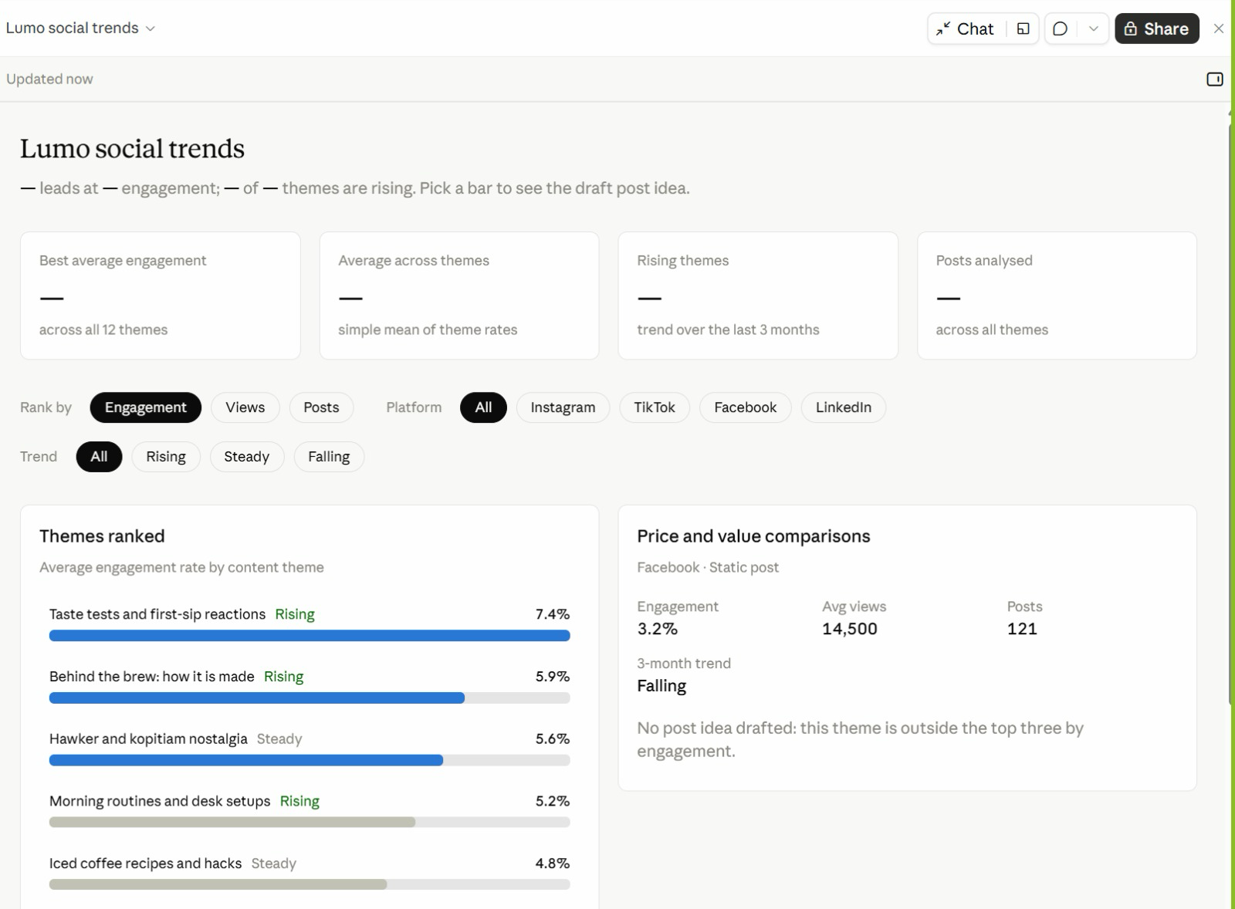
Figure 7 — From the Class: Lumo Social Trends. A Live Artefact built in class from the social trends research.
1. Filters — Rank by engagement, views or posts; filter by platform and trend.
2. Themes ranked — Taste tests and first-sip reactions lead at 7.4%, and are rising.
3. Pick a bar — The right-hand card shows that theme's numbers and a draft post idea.
4. Spot the gap — The summary cards show '—'. Ask Claude to fix them — always check the numbers.
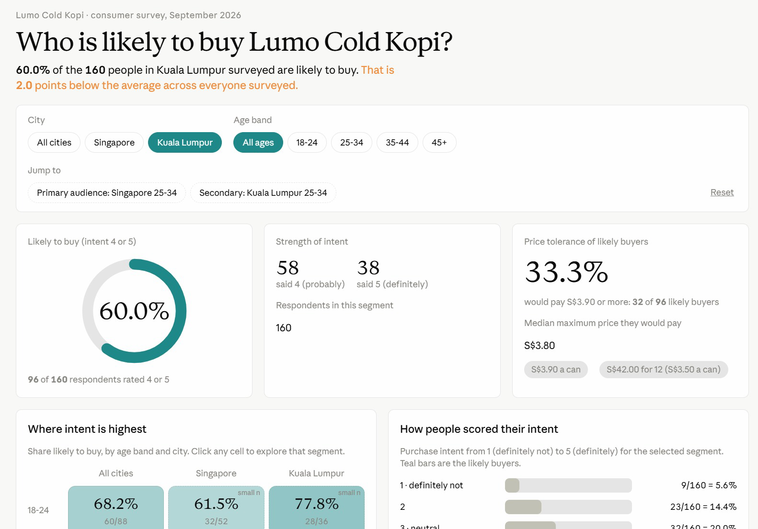
Figure 8 — From the Class: Who Is Likely to Buy?. A Live Artefact on the consumer survey, filtered here to Kuala Lumpur.
1. Filters — City and age band; Jump to opens the primary and secondary audiences.
2. Headline — 60.0% of 160 KL respondents are likely to buy — 2 points below the overall average.
3. Price tolerance — A third of likely buyers would pay S$3.90 or more.
4. Explore — Click any city and age cell to open that segment; small samples are flagged.
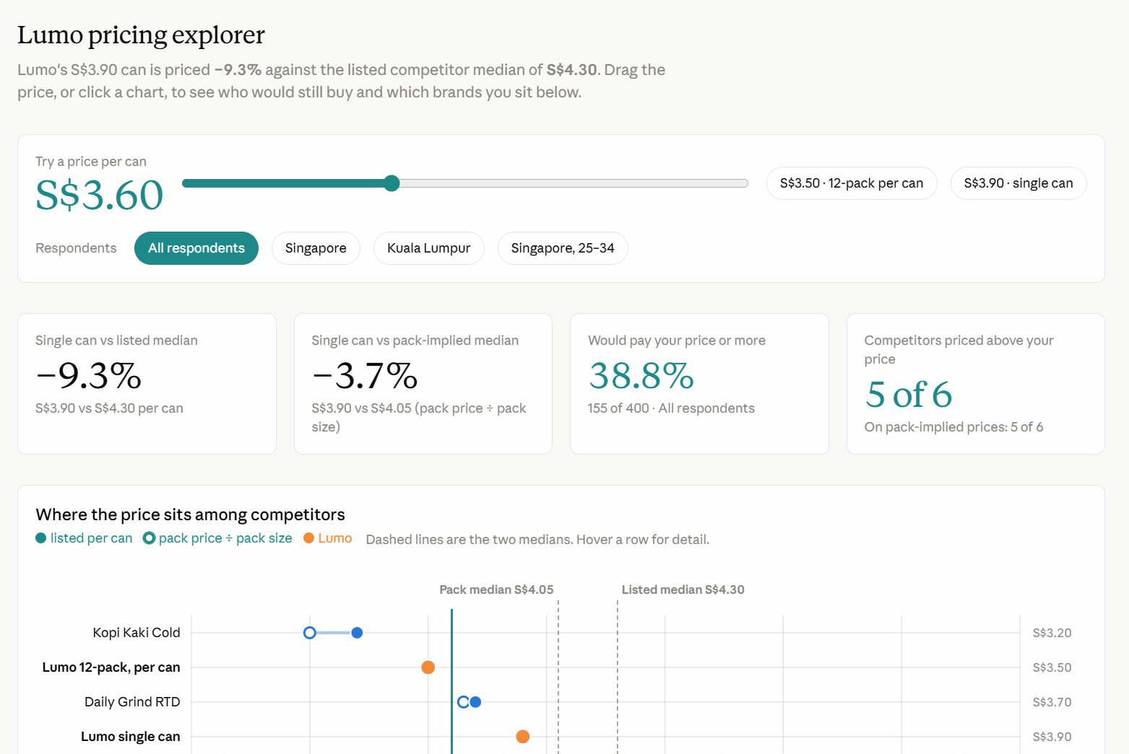
Figure 9 — From the Class: Lumo Pricing Explorer. Drag the price and every card recalculates who would still buy.
1. Price slider — Drag it, or pick S$3.50 (12-pack) or S$3.90 (single can).
2. Against competitors — Lumo's S$3.90 can is 9.3% below the S$4.30 competitor median.
3. The chart — Listed and pack prices per can, with both medians as dashed lines.
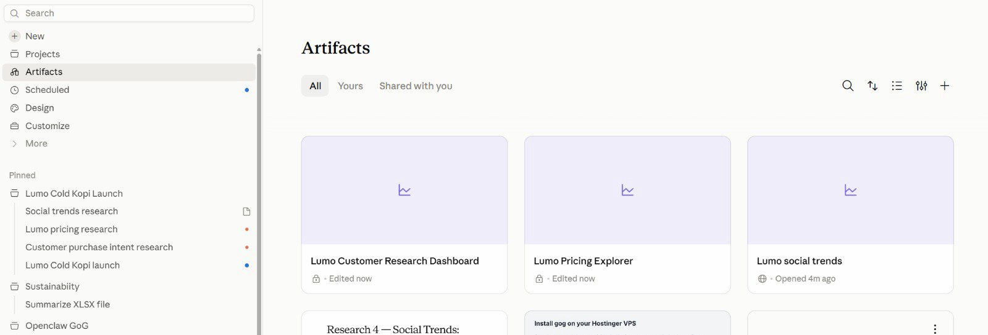
Figure 10 — All Your Artefacts in One Place. Artifacts in the sidebar lists everything you have built, across every project.
1. Artifacts — Open, search, sort and filter all your artefacts.
2. Lock or globe — A lock means private; a globe means shared by link.
3. Pinned — The Lumo project and its sessions stay pinned in the sidebar.

Topic 02 — Connectors, Skills and Plugins
Claude's tools · Drive and Gmail · tool calls · data analysis · the context window · Slides and Docs · Agent Skills · plugins and mods
Key concepts
Concept | What it means
Tools | What Claude can DO: search the web, run code, create files — and reach Drive or Gmail through a connector.
Tool calls | Each action shows as a step in Claude's reply. Click it to see the tool, its input and what came back.
Connectors and approval | Drive and Gmail add their own tools. Reading runs freely; sending an email waits for your approval.
Data analysis | Claude writes and runs code on your CSV or Excel file, so the numbers are calculated — and you can check the code.
Skills | HOW Claude does a job: a SKILL.md of steps, rules and checks, loaded when your request matches its description.
Built-in skills | pptx, xlsx and docx load by themselves when you ask for a deck, a workbook or a document.
/skill-creator | Do the task once, verify it, save it as a skill — then use it, find the gaps and update it.
Plugins and mods | A plugin bundles skills and tools someone packaged. A mod changes Claude's own interface.

Tools and skills
Two words run through this topic. A tool is one action Claude can take; a skill is the know-how for a whole job, which tells Claude which tools to use and in what order.
A tool — what Claude can DO | A skill — HOW Claude does a job
One action: search, read, run code, create a file, send. | A SKILL.md of steps, rules and checks for one kind of job.
Built in (web search, code, files) or added by a connector. | Built in (pptx, xlsx), written by you, or from a plugin.
Claude picks one by matching your request to its description. | Loads when your request matches its description.
Each call shows in the reply: the tool, its input, its result. | Tells Claude which tools to use, in what order.
Lumo: Google Drive search_files finds the budget sheet. | Lumo: lumo-brand-voice applies the rules to every post.

Claude's built-in tools
Claude can already do these before you connect anything:
Tool | What it does
Web search and fetch | Finds and reads current web pages — competitor news, prices, trends — and cites them.
Code execution | Writes and runs Python on your files: counts, tables, charts. Lab 3's dashboard, Lab 5's analysis and Lab 9's video.
File creation | Makes real .xlsx, .pptx, .docx and .pdf files you download and open. Lab 5.
Artefacts | Builds an interactive page — a dashboard, a tracker — that stays in your workspace. Lab 3.
Project files | Reads the project's context and writes outputs to its files — the brief, the calendar. Every lab.
Connectors | Add more tools from outside apps: Google Drive, Gmail, Calendar and others. Lab 4.

How Claude uses a tool
1. You ask — “Compare the Drive budget with the brief.”
2. Claude picks a tool — It matches the job to each tool's description — here, Google Drive.
3. It calls the tool — With inputs it chooses: search_files, query “Lumo Launch”.
4. It reads the result — Two CSV files come back — so it calls read_file_content next.
5. It answers, or asks — Reading just runs. Sending an email waits for your approval.
Every tool call appears as a step in Claude's reply. Click it to see the tool, what Claude passed in and what came back. These are the calls behind Lab 4, Block 1:
WHAT CLAUDE DID — the tool calls behind Lab 4, Block 1
1. Google Drive · search_files("Lumo Launch")
→ 1 folder with 2 CSV files
2. Google Drive · read_file_content(lumo-launch-budget.csv)
→ 5 lines, total S$60,000
3. Google Drive · read_file_content(lumo-launch-timeline.csv)
→ 11 milestones; the next is 30 October
4. Project file · read(lumo-launch-brief.md)
→ budget table, total S$60,000
Claude compares the two → 2 lines disagree
5. Google Drive · create_file(lumo-research-brief.docx)
6. Gmail · create_draft("Lumo launch - research and budget check")
7. Gmail · send_message → waits for your approval

Note: Click any step in Claude's reply to see this for yourself. Tool names can differ slightly between connector versions; the pattern does not.

Connectors and the context window
A connector adds tools that reach a service outside the chat. These are the ones this course uses:
Connector | What Claude can do
Google Drive | Search and read Sheets, Docs, Slides and PDFs; upload files; create folders; save Claude's output back to Drive.
Gmail | Search and read mail, draft messages, send / reply / forward with approval, and manage labels.
Google Calendar | View events, find availability, and create or update meetings.
Social and ads tools | Where your workspace has them, connectors for scheduling and ad platforms reach the same way — always with approval.
Approval by default | Claude asks for explicit approval before it sends, replies to or forwards an email.
Where to manage them | Individually from the + menu; account-wide under Customize → Connectors.

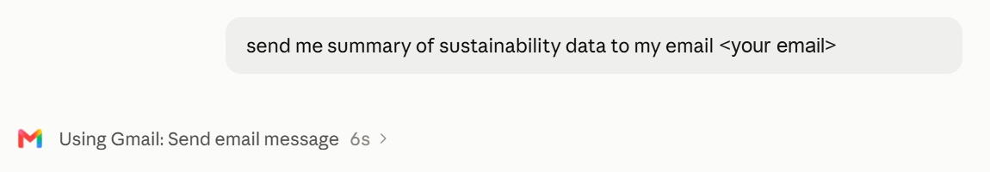
Figure 11 — A Connector at Work: Gmail. One plain request — Claude chose the Gmail connector's Send email action.
1. Ask in plain English — Say what to send and to whom; no menus to find.
2. Watch the tool call — 'Using Gmail: Send email message' names the connector and action. Click › for detail.
3. Stay in control — Ask for a draft first when the email goes to anyone but you.
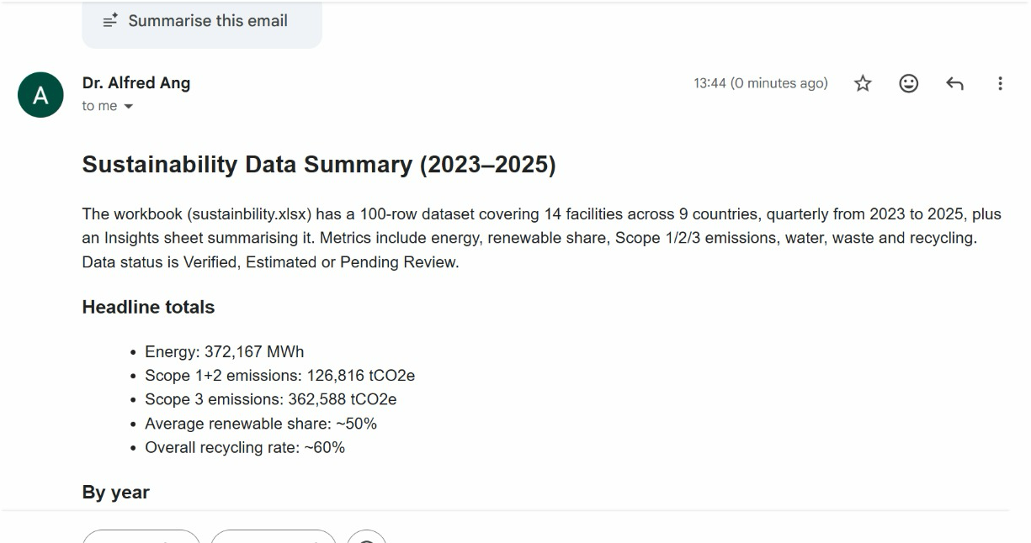
Figure 12 — The Result in Gmail. The summary arrived seconds later, written from the project's sustainability workbook.
1. Read from the file — Claude summarised the workbook: 14 facilities in 9 countries, 2023–2025.
2. Ready to read — Headings and bullets, formatted for email.
3. Verify — Spot-check one total against the source file before you forward it.
Tool permissions and approval
Rule | In practice
Read tools run | Search, read and list change nothing, so they run without asking.
Write tools ask | Send, reply, create an event or delete ask for your approval by default.
See every tool | Customize → Connectors → open a connector to see each tool it adds and what it may do.
On per session | Toggle a connector on from the + menu only for the jobs that need it.
Scope the data | Name the folder, label or dates — “the Lumo Launch folder”, not “my Drive”.
You approve | Read the draft before you click. Claude drafts; the decision stays yours.

Connectors at work: six everyday jobs
Each of these is one prompt once the connectors are on. Lab 4 runs three of them on the Lumo files.
Everyday job | Tools | The prompt you would send
Meeting prep | Gmail · Calendar | Before my 3pm with Kopi Corner, summarise this month's emails with them and list the open questions.
Inbox triage | Gmail | Find customer emails from the last three days that have no reply, and draft replies for my approval.
Budget check | Drive | Compare the Q4 budget sheet with the brief, line by line, and flag every difference. Do not pick one.
Find a file | Drive | Find the latest signed stockist agreement and tell me its renewal date and notice period.
Book a meeting | Calendar · Gmail | Find 45 minutes next week when the four leads are free, and draft the invite.
Weekly update | Drive · Gmail | Summarise what changed in the Lumo Launch folder this week and draft the email to my manager.

When a tool goes wrong
What you see | Likely cause | What to do
“Insufficient scope” | Connected without file access | Settings → Connectors → Reconnect, and accept read access.
An answer with no Drive step | Connector off for this session | + → Connectors → switch it on; start with “Using Google Drive…”.
It read the wrong file | The search matched several files | Name the folder and file: Lumo Launch/lumo-launch-budget.csv.
Numbers that look estimated | No code was run | Ask it to use code and show the totals; check one figure yourself.
Slow replies, usage drains fast | Too many connectors switched on | Turn off the ones this job does not need.

Keeping the context window lean
The context window is all the information the model can “see” when producing a response. Five levers decide what goes into it:
Lever | What it adds
Conversation | Your prompt. The messages you send, including both text and attachments.
Project context | The files, folders and Drive folder the project reads from.
Connectors | The connected tools Claude can pull data from, and take actions in.
Skills | A set of instructions Claude follows for a repeatable workflow.
Instructions & memory | Project rules you wrote, and facts the project has learned.

Every lab today pulls one of these levers — context in Lab 1, connectors in Lab 4, skills in Labs 5–7, and memory in Lab 10.
A window that fills up costs you in four ways:
Problem | What happens
Context rot | Performance degrades. Recall of specific facts gets worse, the model starts confusing similar entities, and reasoning quality drops.
Tool confusion | Claude sees every tool definition. The more options competing for its attention, the more likely it picks the wrong one or fills in the wrong parameters.
Slower responses | The model processes every token on every turn. A bigger context means more work per message, which means longer waits before you see a reply.
Eats up your usage faster | Your entire context gets resent with each new message — so more tokens are burned per turn, and your limits are reached sooner.

The fix is housekeeping: one job per thread, only the connectors you need, and only the files the job actually reads.

Lab 4 — Connect Google Drive and Gmail
Objective: By the end of this lab you can connect Google Drive and Gmail and use their tools to reconcile, search, save and draft, sending only what you approve.
Scenario: The launch budget and timeline live in Google Drive. You connect Drive and Gmail, and the project reconciles the Drive budget against the launch brief — they disagree on two lines — saves the research brief to Drive and emails you an approved summary. Then two everyday jobs: find the next milestones in Drive and draft a reminder in Gmail, reading the tool calls behind each.
You will build: Drive and Gmail connected, the budget reconciled, an approved summary emailed to yourself, a milestone list from Drive and a reminder saved as a Gmail draft.
Tools: Claude Projects, Google Drive connector, Gmail connector, tool calls.
In the project
Part | In this lab
Instructions — HOW | Uses: never send without approval — Claude drafts the email, you approve it.
Context — WHAT | Uses: the launch brief's budget, compared line by line with the Drive sheet.
Folder — WHERE | Reaches out: the Lumo Launch folder in Google Drive and your Gmail, by connector.
Scheduled — WHEN | Not used — runs when you send the prompt.

Lab files
- Prompt PDF: labs-threads/lab-04-connect-drive-and-gmail/lab-04-connect-drive-and-gmail.pdf
- labs-threads/lab-04-connect-drive-and-gmail/data/Lumo Launch/lumo-launch-budget.csv
- labs-threads/lab-04-connect-drive-and-gmail/data/Lumo Launch/lumo-launch-timeline.csv
Tips
Turning connectors on
Click the + in the chat composer, hover Connectors, and toggle on only Google Drive and Gmail. You can manage them later under Customize → Connectors.
If Claude says "insufficient scope"
The connector is linked but was authorised without permission to read files. Fix it in Settings → Connectors → Google Drive → Reconnect, and accept the read access Google asks for. Then tell Claude to try again.
Seeing the tools Claude used
Every tool Claude calls appears as a step in its reply, such as *Searched Google Drive*. Click the step to see the tool's name, what Claude passed in and what came back.
Step-by-step
This lab has three blocks. Block 1 reconciles the budget and emails you an approved summary. Block 2 searches Drive for the milestones due next and asks Claude to list the tools it called. Block 3 searches Gmail and saves a reminder as a draft.
Note: Replace <YOUR EMAIL> with your own address in Blocks 1 and 3. Send lab emails only to yourself.
1. Upload the Lab 04 data/Lumo Launch folder to your Google Drive.
Why: In real work the files are already there; the upload stands in for the shared team drive.
2. In the project, click + → Connectors and switch on Google Drive and Gmail, signing in to Google.
Why: Accept the read access Google asks for. A connector that shows Connected without read access fails with "insufficient scope".
3. Send Block 1 with your own email address in place of <YOUR EMAIL>.
Why: No files are attached this time — the project reaches Drive itself.
Block 1 — RECONCILE
Send this in the project:
PROMPT — copy into Claude
Using Google Drive, open the "Lumo Launch" folder.

1. Read lumo-launch-budget.csv and lumo-launch-timeline.csv.
2. Compare the budget sheet, line by line, with the budget in
lumo-launch-brief.md from our project context. Show both in one
table and flag every line where they disagree. Do not decide
which is right.
3. Upload lumo-research-brief.docx from Lab 2 into the same Drive
folder.
4. Draft an email to <YOUR EMAIL> with the subject
"Lumo launch - research and budget check": three bullet points
from the research brief, the budget table with the disagreements
flagged, the next milestone from the timeline, and a link to the
brief in Drive.

Show me the draft. Do not send it until I approve.

Read the budget table and the draft in full before you approve the email.
4. Read the budget table Claude produces.
Why: Both total S$60,000, but Instagram is S$18,000 in the Drive sheet and S$20,000 in the brief, and Influencers is S$12,000 against S$10,000.
5. Confirm Claude flagged both lines instead of choosing one.
Why: That is your Lab 1 instruction at work. Two sources disagreeing is a decision for a human, not a guess for Claude.
6. Check that lumo-research-brief.docx now sits in the Lumo Launch folder in Drive.
Why: Saving outputs back to the team's folder is what makes the work findable by colleagues.
7. Read the draft email in full, then approve it.
Why: Gmail sends only after your explicit approval. Check the figures against the table before you click.
8. Open your inbox and confirm the email arrived with the Drive link working.
Why: Close the loop: an email you did not check arrived is an email you hope arrived.
9. Send Block 2 to find the milestones due from 6 to 20 November.
Why: The prompt names no file. Claude must search Drive, then read what it found — two tool calls you never asked for by name.
Block 2 — FIND
Then send:
PROMPT — copy into Claude
Search my Google Drive for the Lumo launch timeline.

1. List every milestone due from 6 to 20 November 2026 in a
table: date, milestone, owner and status.
2. Then list the tools you called to answer this, in order:
the tool's name, what you passed to it, and what it returned.

Click the Drive steps in Claude's reply and compare them with the tool list it gave you.
10. Click the Drive steps in Claude's reply and compare them with the tool list it gave you.
Why: Each step shows the tool, its input and its result — a search, then a file read. This is how you check where an answer came from.
11. Check the milestone table.
Why: Three milestones, all Not started: 6 November, launch deck and campaign brief (Marketing lead); 13 November, brand-voice skill and social calendar (Social lead); 20 November, creator content approved (Partnerships lead).
12. Send Block 3 with your own email address in place of <YOUR EMAIL>.
Why: Two Gmail tools this time — one searches your mail, one creates a draft — plus a Drive read. None of them sends anything.
Block 3 — REMIND
Then send:
PROMPT — copy into Claude
Using Gmail and Google Drive:

1. Search my Gmail for the email with the subject
"Lumo launch - research and budget check" and tell me when
it arrived.
2. From lumo-launch-timeline.csv in Drive, find the milestone for
the Shopee and Lazada store pages: its owner and due date.
3. Draft an email to <YOUR EMAIL> with the subject
"Reminder: store pages due <due date>", reminding its owner
of what is due and when.

Save the reminder as a Gmail draft. Do not send it.

Open Gmail → Drafts and check the reminder is there, unsent.
13. Open Gmail → Drafts and check the reminder.
Why: The store pages belong to the E-commerce lead and are due Friday 27 November 2026. The reminder is a draft, not a sent email, and Claude reported when the Block 1 email arrived.
Check
You are done when: Google Drive and Gmail are connected. Claude read both CSV files from the Lumo Launch folder, showed a budget table totalling S$60,000 on both sides, and flagged Instagram (S$18,000 vs S$20,000) and Influencers (S$12,000 vs S$10,000) without choosing between them. lumo-research-brief.docx is in the Drive folder, and the approved summary email arrived in your own inbox with a working link. Block 2 listed the three milestones due from 6 to 20 November with their owners and named the Drive tools it called. Block 3 found the Block 1 email in Gmail and saved a reminder about the E-commerce lead's store pages, due 27 November 2026, as a draft — nothing else was sent.

From the class
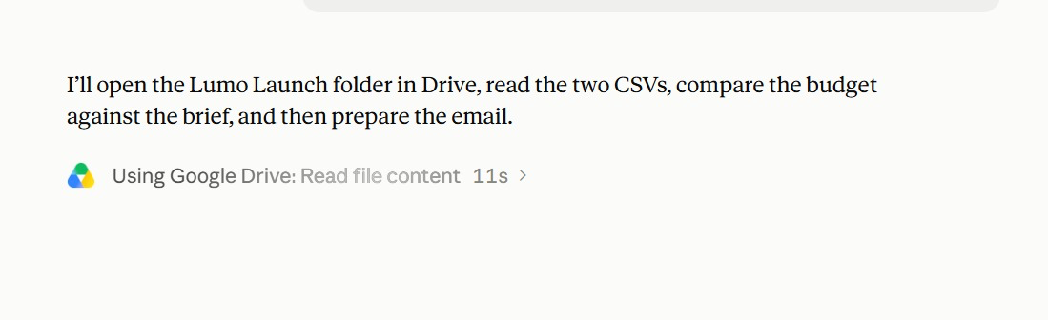
Figure 13 — Lab 4 in Class: Reading from Google Drive. Claude states its plan, then calls the Google Drive connector.
1. Plan first — Open the Lumo Launch folder, read both CSVs, compare the budget with the brief, then email.
2. The tool call — 'Using Google Drive: Read file content' — the connector at work.
3. Watch it — Each tool call shows its time; click › to see what was read.
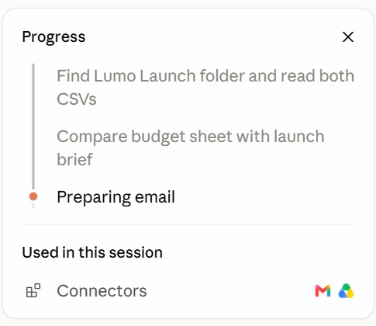
Figure 14 — Following the Progress Panel. The progress panel ticks off each step and lists what the session used.
1. Steps — Find the folder → compare budget and brief → prepare the email.
2. Current step — The orange dot marks the step in progress.
3. Used in this session — The connectors it called: Gmail and Google Drive.
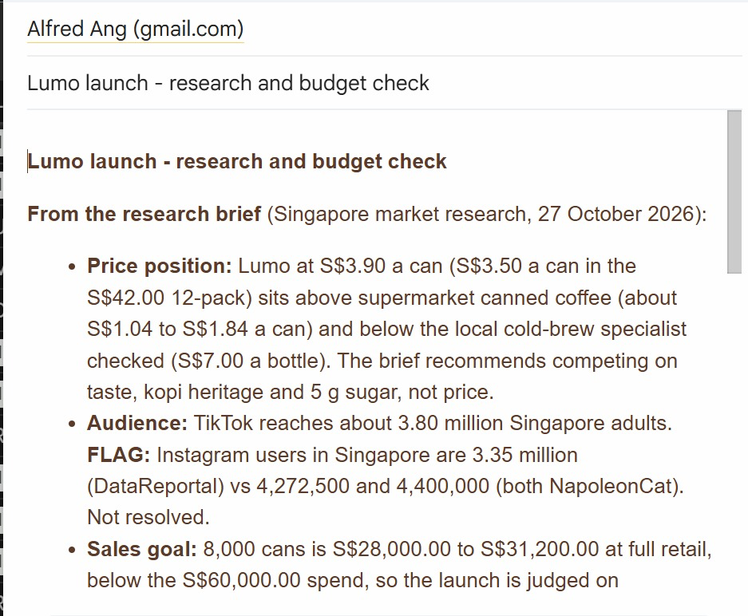
Figure 15 — The Lab 4 Email. The research and budget check, written into Gmail from the Drive files.
1. From the brief — Price position, audience and sales goal, quoted from the research brief.
2. FLAG — Conflicting Instagram figures are flagged, not hidden — resolve each FLAG.
3. The numbers — 8,000 cans is S$28,000–31,200 at retail, below the S$60,000 spend.

Analysing data with Claude
Ask Claude a question about a CSV or Excel file and it uses its code tool: it writes Python, runs it on the file and reads the result. The work runs in five moves:
1. Attach the data — A CSV or Excel file — the 400-row Lumo survey.
2. Define the terms — “Likely to buy” means intent 4 or 5 — say so.
3. Claude runs code — Python reads the file, counts, and draws the chart.
4. Check the method — Click the code step: right column, right filter?
5. Take the output — Tables, a chart, and an .xlsx workbook to download.
The numbers come from code that ran on your file — not from the model's memory.
Six questions to ask of your data
Question type | The prompt you would send
Segment | Likely to buy by city and by age band — count, base and %.
Compare | Which discovery channel has the highest average purchase intent?
Threshold | What share would pay S$3.50 or more, by city?
Clean | Find duplicate respondent IDs, blanks and impossible values. List them; do not delete.
Trend | Chart responses per week from response_date and tell me if any week is unusual.
Report | Save the tables and one chart as an Excel workbook with a Summary sheet.

Four checks before you trust the numbers
Check | How
Define every term | “Likely to buy” must mean intent 4 or 5 — write it in the prompt, or Claude chooses for you.
Ask for the base | A percentage without its count and base cannot be checked: 63% of what? Ask for 152 of 240.
Reconcile the totals | The segments must add back to the whole: 240 + 160 = 400 respondents, 152 + 96 = 248 likely to buy.
Check one figure yourself | Filter the CSV in Excel for one row of the table. If it matches, you can trust the method.

Slides, Docs and built-in skills
Format | What it is
Slides | A deck Claude builds and you edit in place — download as PowerPoint or PDF for the meeting.
Docs | A living document — a campaign brief, a plan — that you and Claude edit and comment on together.
Dashboards | A page of live numbers — the Live Artefact you build in Lab 3 is one.
Built-in skills | Claude's pptx, docx and xlsx skills load on their own when your request needs a file.

You never name the skill. Ask for a deck or a document; Claude picks the format and the skill that builds it.

Lab 5 — Analyse the Survey, Then Build the Deck and Brief
Objective: By the end of this lab you can analyse survey data with Claude's code tool and save it to Excel, then produce a launch deck in Slides and a campaign brief in Docs.
Scenario: Before the deck, the numbers. Claude analyses the 400-row survey by writing and running code, and saves the tables and a chart as an Excel workbook. Then it builds the Friday deck in Slides and the campaign brief in Docs, choosing its built-in skills itself. You check every figure and download the deck as PowerPoint.
You will build: A survey analysis workbook (lumo-survey-analysis.xlsx), an eight-slide launch deck in Slides (downloaded as .pptx) and a campaign brief in Docs.
Tools: Claude Projects, code execution, built-in skills (xlsx, pptx, docx), Slides, Docs.
In the project
Part | In this lab
Instructions — HOW | Uses: follow the brand guidelines for anything customer-facing.
Context — WHAT | Uses: the brand kit, for the name, tagline, price and claims.
Folder — WHERE | Uses: attach the survey CSV; lumo-survey-analysis.xlsx is saved and the deck downloads as .pptx.
Scheduled — WHEN | Not used — runs when you send the prompt.

Lab files
- Prompt PDF: labs-threads/lab-05-launch-deck-and-brief/lab-05-launch-deck-and-brief.pdf
- labs-threads/lab-05-launch-deck-and-brief/data/lumo-consumer-survey-2026.csv
Step-by-step
This lab has two blocks. Block 1 has Claude analyse the survey by writing and running code, and save the result as an Excel workbook. Block 2 builds the launch deck and the campaign brief.
Note: You do not name a skill in either block. Ask for a workbook, a deck or a document; Claude picks the format and the built-in skill.
1. In the project, attach lumo-consumer-survey-2026.csv and send Block 1.
Why: Everyone analyses the same 400-row survey. Claude's code tool writes Python, runs it on the file and reads the result — you never write the code.
Block 1 — ANALYSE
Attach lumo-consumer-survey-2026.csv and send:
PROMPT — copy into Claude
Analyse the attached survey with code. Count "likely to buy" as
purchase_intent 4 or 5.

1. Likely to buy by city, and by age band: count, base and %.
2. Willing to pay S$3.50 or more (max_price_sgd), by city.
3. Likely to buy among 25-34s in Singapore only.
4. One chart: likely-to-buy % by age band.
5. Save it all as lumo-survey-analysis.xlsx: a Summary sheet,
one sheet per table, and the chart.

Show the totals so I can check them, then give me three
findings in one sentence each.

Click the code step and check the totals before you use any number.
2. Click the code step in Claude's reply and read what it ran.
Why: Find the line that counts purchase_intent 4 or 5. Checking the method is how you know the numbers were calculated, not guessed.
3. Check the tables against these figures.
Why: Singapore 152 of 240 (63%), Kuala Lumpur 96 of 160 (60%). By age: 18-24 60 of 88 (68%), 25-34 112 of 152 (74%), 35-44 50 of 96 (52%), 45+ 26 of 64 (41%). Would pay S$3.50 or more: Singapore 143 (60%), Kuala Lumpur 85 (53%). 25-34s in Singapore: 72 of 96 (75%).
4. Download lumo-survey-analysis.xlsx and open it in Excel.
Why: The xlsx built-in skill made a real workbook: a Summary sheet, one sheet per table and the chart.
5. Ask one follow-up question about the data: Which coffee frequency group is most likely to buy?
Why: Expect 1-2 times a week at 52 of 76 (68%), with daily drinkers lowest at 90 of 156 (58%). Follow-up questions are cheap — the data is already loaded.
6. Send Block 2.
Why: No attachments: the research brief, the dashboard data and the brand kit are all already in the project.
Block 2 — BUILD
Then send:
PROMPT — copy into Claude
Using our research brief, the Market Insights dashboard and the
brand kit, create two things for Friday's launch meeting.

1. A launch deck in Slides, eight slides:
1 Title - Lumo Cold Kopi: Kopi, Chilled Right
2 The opportunity - the three survey numbers that matter most
3 Who we are for - 25-34s in Singapore, with the evidence
4 Competitors - a price ladder chart with Lumo highlighted
5 Where they find us - a discovery channel chart
6 The campaign - message, channels and dates
7 Budget - the S$60,000 split, noting the two open questions
8 Next steps and owners

Use the Lumo brand colours. Real charts, not pictures of charts.

2. A campaign brief in Docs: objective, audience, key message,
proof points, channels, budget, timeline, KPIs, and a "claims
we must not make" section.

Every number must come from the research brief or the dashboard.
List the source of each number at the end of the brief.

Check every figure against the research brief and your analysis.
7. Open the deck when it appears and page through all eight slides.
Why: Check the charts are real charts — click one; a real chart has editable data behind it.
8. Check slide 2 and slide 4 against your research.
Why: 62% likely to buy, 74% among 25-34s, Instagram 34%; a price ladder from S$3.20 to S$5.60 with Lumo at S$3.90.
9. Check slide 7.
Why: The S$60,000 split should carry the two open questions from Lab 4 — Instagram and Influencers — not quietly pick one figure.
10. Open the campaign brief in Docs and read the "claims we must not make" section.
Why: It should rule out "healthy" and any claim the product sheet does not support. This section protects every post you write later.
11. Ask for one change to each, for example: Shorten slide 6 to three bullets.
Why: Slides and Docs are edited in place by conversation, the same way as an artefact.
12. Download the deck as PowerPoint and open it.
Why: The download is the file you take into the meeting — check the charts survived.
Check
You are done when: The analysis shows Singapore 152 of 240 (63%) and Kuala Lumpur 96 of 160 (60%) likely to buy, 25-34s at 112 of 152 (74%) and 72 of 96 (75%) among 25-34s in Singapore, and lumo-survey-analysis.xlsx opens in Excel with a Summary sheet, the tables and a chart. The deck has eight slides in the Lumo colours, with real charts for the price ladder and the discovery channels, the survey figures 62%, 74% and 34%, and a budget slide that shows S$60,000 with the Instagram and Influencers lines marked as open questions. The campaign brief in Docs has all nine sections, including "claims we must not make", and lists a source for every number. The deck opens in PowerPoint with its charts intact.

Agent Skills
An Agent Skill is a folder of instructions Claude loads on demand, so a routine runs the same way every time. A skill has three layers, and only the first is always in context:
Layer | What it holds | When Claude loads it
Metadata | Skill name and description. | Always in context — this is all Claude sees until the skill is triggered.
Instructions | The step-by-step workflow, written in a SKILL.md. | Loaded when the skill is triggered.
Resources | Supporting documents, templates and examples. | Loaded only when the skill needs them.

Inside a real SKILL.md
This is the skill you build in Lab 6. It is plain text: the metadata at the top, then the rules and steps, then the resources it can call on.
SKILL.md — lumo-brand-voice, as /skill-creator writes it in Lab 6
---
name: lumo-brand-voice
description: Use when writing or reviewing any customer-facing
Lumo Kopi content - social posts, captions, emails, video
scripts or ads.
---
# Lumo brand voice

## Rules
- Prices as S$3.90 and S$42.00 - never $3.9 or SGD42.
- No "healthy", medical or weight-loss claims.
- At most one Singlish word.
- #LumoKopi on every post; no more than five hashtags.
- End with one clear call to action.

## Steps
1. Draft or rewrite in the Lumo voice.
2. Remove any claim not in lumo-product-sheet.md.
3. Run the checklist and show the result.

## Resources
- examples.md: two before-and-after rewrites

Note: Top: metadata, always in context. Rules and steps: loaded when the skill is used. examples.md: read only when needed.
Four kinds of skill
Kind | Who writes it | How it loads | In this course
Built-in | Anthropic | By itself when you ask for a file | pptx, xlsx, docx — Lab 5
Your own | You, with /skill-creator | When a request matches its description | lumo-brand-voice — Lab 6
From a plugin | The plugin's author | The same, or by its /plugin:command | marketing:brand-review — Lab 7
Shared by your team | An admin or a colleague | Provided to everyone in the organisation | Your company's house style

The description decides when it loads
Description | Verdict | Why
Brand voice. | Too vague | Says nothing about when — Claude rarely loads it.
Rewrites Instagram captions. | Too narrow | Will not load for an email, a video script or an ad.
Use for all writing. | Too broad | Loads for internal notes and meeting minutes too.
Use when writing or reviewing any customer-facing Lumo Kopi content - social posts, captions, emails, video scripts or ads. | Good | Names the job, the brand and every format it covers.

Lab 6 tests this: Block 3 never names the skill, so only the description can load it.
Do, Verify, Save, Update
You never write a skill from a blank page. You do the task once, then save the verified routine:
1. Do — Do the task together with Claude once, step by step.
2. Verify — Review and refine until the output is right.
3. Save — Turn it into a skill using the /skill-creator skill.
4. Use and update — Use it on new work, find the gap, and save the fix over it — Claude confirms first.
Skills worth writing at work
Any routine you repeat, with rules someone could forget, is a skill waiting to be written.
Skill | What it does
weekly-status-report | Every Monday: reads the project folder and inbox, writes five bullets in a fixed format. Uses Drive and Gmail.
meeting-minutes | Turns a transcript into decisions, actions, owners and due dates — the same table every time.
customer-reply | Drafts replies in the house tone; never promises a refund or a price the policy does not allow.
proposal-deck | Builds a client proposal in the company template, using the built-in pptx skill.
expense-check | Checks a claims spreadsheet against the policy limits and flags each breach with its rule.
job-ad-writer | Writes a job ad in the house format, then checks it for biased or exclusionary wording.

When a skill goes wrong
What you see | Likely cause | What to do
The skill does not load | The description does not mention this job | Add the job and its words to the description.
It loads when it should not | The description is too broad | Narrow it: name the brand, the formats, the audience.
It skips a rule | The rule is vague | Rewrite it as a check: “price written as S$3.90”.
A new kind of job goes wrong | The skill has no rule for it | Update it with /skill-creator — Lab 6, Block 4.
Colleagues get different results | Each keeps a different copy | Share one skill, or package it in a plugin.

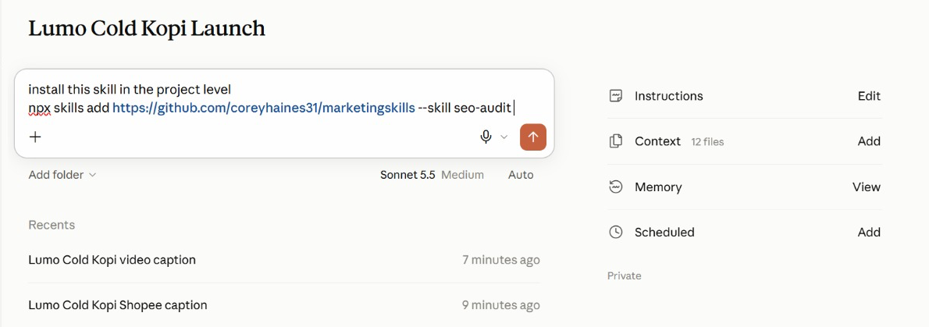
Figure 16 — Install a Published Skill. Ask Claude to install a skill from GitHub into the project.
1. The request — 'Install this skill in the project level', then the npx skills add command.
2. Project level — The skill is available in this project, beside the brand-voice skill you write in Lab 6.
3. Check the source — Read a third-party skill's SKILL.md first — it runs with your access.

Lab 6 — Capture the Brand Voice as an Agent Skill
Objective: By the end of this lab you can capture the brand voice as an Agent Skill with /skill-creator, read its SKILL.md, use it on workplace messages and update it.
Scenario: Every post and customer email has to sound like Lumo. You rewrite five off-brand captions until they are right, save the routine as a lumo-brand-voice skill with /skill-creator and read its SKILL.md. Then you use it on three waiting messages, spot the gap it leaves, and update the skill so every future reply closes it.
You will build: A lumo-brand-voice Agent Skill, read in its SKILL.md, used on three workplace messages, then updated with a customer-reply section and retested.
Tools: Claude Projects, Agent Skills, /skill-creator.
In the project
Part | In this lab
Instructions — HOW | Uses: the never-say-healthy rule becomes a check inside the skill.
Context — WHAT | Uses: the brand guidelines the skill is written from, and the product sheet its replies may quote.
Folder — WHERE | Uses: attach the captions, then the customer messages; the skill saves to Customize → Skills.
Scheduled — WHEN | Not used — runs when you send the prompt.

Lab files
- Prompt PDF: labs-threads/lab-06-brand-voice-skill/lab-06-brand-voice-skill.pdf
- labs-threads/lab-06-brand-voice-skill/data/lumo-sample-captions.txt
- labs-threads/lab-06-brand-voice-skill/data/lumo-customer-messages.txt
Step-by-step
This lab has five blocks, sent at different times. Block 1 does the work once so you can verify it. Block 2 saves it as a skill: type /skill-creator in the composer, then paste the block. Block 3 uses the saved skill on three workplace messages without naming it. Block 4 updates the skill, again after /skill-creator, and Block 5 tests the update in a fresh thread.
Note: Blocks 2 and 4 begin with you typing /skill-creator in the composer — it is not part of the pasted text.
1. Open lumo-sample-captions.txt and read the five captions.
Why: Each breaks at least one brand rule — a wrong price format, a health claim, too much slang, too many hashtags.
2. In the project, attach the file and send Block 1.
Why: This is the Do step of Do · Verify · Save · Update. You never write a skill from a blank page.
Block 1 — DO
Attach lumo-sample-captions.txt and send this first, on its own:
PROMPT — copy into Claude
Rewrite the five captions in the attached file in the Lumo
brand voice, following lumo-brand-guidelines.md.

For each caption, show:
- the original
- your rewrite
- every rule you applied, by name
- any claim you removed, and why

Then run these checks on each rewrite and show the result:
price written as S$3.90; no "healthy" or medical claims; at
most one Singlish word; #LumoKopi present; no more than five
hashtags; ends with one clear call to action.

Now stop and read the output. Ask for changes until every rewrite sounds right. Whatever you settle on here is exactly what the skill will reproduce.
3. Check each rewrite against the brand guidelines and refine until all five are right.
Why: This is the Verify step. Ask for changes in plain English; you are teaching the routine by correcting it.
4. Type /skill-creator in the composer, then paste Block 2 and send.
Why: skill-creator writes the SKILL.md from the run you just verified — name, description, instructions and examples.
Block 2 — SAVE
Type /skill-creator in the composer, then paste this:
PROMPT — copy into Claude
Create a skill called lumo-brand-voice from what we just did.

Description: Use when writing or reviewing any customer-facing
Lumo Kopi content - social posts, captions, emails, video
scripts or ads.

It should rewrite or draft content in the Lumo voice, apply the
brand rules, remove claims we cannot prove, and finish with the
same checklist of checks we used. Include two of today's
before-and-after examples as a resource.

Approve the skill when Claude shows it to you, then open Customize → Skills and read its SKILL.md.
5. Read the skill Claude proposes, especially its description, and approve it.
Why: The description is the one part always in context. It decides when the skill loads, so it must say WHEN to use it.
6. Open Customize → Skills, open lumo-brand-voice and read its SKILL.md.
Why: Find the four parts: the name and description at the top, the rules and steps below them, and the examples file beside it. The whole skill is plain text you can read and edit.
7. Start a new thread, attach lumo-customer-messages.txt and send Block 3.
Why: Three messages waiting for a reply — the same file for everyone. The prompt does not name the skill, so if it loads, its description did its job.
Block 3 — USE
Start a new thread in the project, attach lumo-customer-messages.txt and send:
PROMPT — copy into Claude
Draft replies to messages 1 and 2 in the attached file, and
rewrite the flyer line in message 3 so it is ready to print.

The prompt never names the skill. Check the reply's steps: lumo-brand-voice should have loaded by itself.
8. Check that lumo-brand-voice loaded, then read the flyer line and the café reply.
Why: The flyer line must lose "super healthy" and "best kopi in Singapore" and show S$3.90. The café asks for a wholesale price that is not in the product sheet — the reply must not invent one.
9. Read the reply to message 1 closely.
Why: Does it promise a refund or a new pack? The skill has no rule for customer replies yet. Fix that gap once, in the skill, not in every prompt.
10. Type /skill-creator in the composer, then paste Block 4 and approve the change.
Why: This is the Update step. Claude shows the change and confirms before it replaces the saved skill.
Block 4 — UPDATE
Type /skill-creator in the composer, then paste this:
PROMPT — copy into Claude
Update the lumo-brand-voice skill. Add a section for replies to
customers and stockists:
- thank them, and apologise once if something went wrong;
- never promise a refund, replacement, discount or any price
that is not in lumo-product-sheet.md;
- say the team will reply within two working days;
- sign off "- The Lumo Kopi team".

Show me the change before you save over the skill.

Read the change Claude proposes, then approve it.
11. Start a new thread, attach the file again and send Block 5.
Why: A fresh thread proves that the updated skill, not the earlier conversation, made the difference.
Block 5 — RETEST
Start a new thread, attach lumo-customer-messages.txt again and send:
PROMPT — copy into Claude
Reply to message 1 in the attached file.

The reply should follow the new rules without you repeating any of them.
12. Check the new reply to message 1.
Why: No refund or replacement promised, a reply within two working days, and signed "- The Lumo Kopi team". One edit to the skill now changes every future reply, for you and for anyone who uses it.
Check
You are done when: lumo-brand-voice appears under Customize → Skills, and its SKILL.md shows a name, a description that says when to use it, the brand rules and the checklist. In a fresh thread, Block 3 loaded the skill without naming it: the flyer line drops "super healthy" and "best kopi in Singapore" and shows S$3.90, and the café reply does not invent a wholesale price. After Block 4 the skill has a customer-reply section, and the Block 5 reply to message 1 promises no refund, says the team will reply within two working days and signs off "- The Lumo Kopi team".

Skills, plugins and mods
A skill is one routine. A plugin is the whole setup — install the Marketing plugin and you get every skill, command and tool it contains.
 | Skill | Plugin | Mod
Changes | How a task is done | A whole toolkit | Claude's own interface
Contains | One SKILL.md + resources | Skills, tools, agents, hooks | A panel, command, hook or status line
You get it by | Writing it with /skill-creator | Installing from Discover | Asking Claude to make one
Lumo example | lumo-brand-voice | Marketing plugin | A Next Lumo post panel

Mods
- What a mod is — A change to Claude's own interface or behaviour, rather than to the work it does.
- A panel or pane — Something that stays beside the chat and updates — a running checklist, a campaign tracker.
- A status line or toast — A small always-visible signal, such as the active project or remaining usage.
- A slash command — Your own /command that starts a routine you use often.
- A hook — An action that runs automatically on an event — for example, before Claude sends anything.
- Where to find them — Under Customize, alongside Skills, Connectors and Plugins. Ask Claude to make one for you.

Lab 7 — Add the Marketing Plugin and a Mod
Objective: By the end of this lab you can install a plugin, use its namespaced commands alongside your own skill, and build a mod that suggests the next social post.
Scenario: You wrote one skill yourself; now you install a toolkit somebody else packaged. Anthropic's Marketing plugin bundles several marketing skills behind namespaced commands. You install it, use /marketing:campaign-plan to stress-test the launch plan, and run /marketing:brand-review on the deck copy — then compare a plugin with the skill you wrote. Last, you build a mod of your own: a Next Lumo post panel beside the chat that suggests what to post next.
You will build: The Marketing plugin installed, a campaign plan review, a brand review of the launch copy, and a Next Lumo post mod.
Tools: Claude Projects, plugins, mods, Customize.
In the project
Part | In this lab
Instructions — HOW | Uses: plugin commands follow the same project rules.
Context — WHAT | Uses: the brand guidelines, for /marketing:brand-review.
Folder — WHERE | Uses: the research brief, campaign brief and deck; the Next Lumo post mod reads the project.
Scheduled — WHEN | Not used — the mod suggests a post; nothing runs on a timer.

Lab files
- Prompt PDF: labs-threads/lab-07-marketing-plugin/lab-07-marketing-plugin.pdf
This lab has no data folder — it works from what the project already holds.
Step-by-step
This lab has three blocks. Blocks 1 and 2 are commands from the Marketing plugin: install it first, then send Block 1 and, after reading its answer, Block 2. Block 3 asks Claude to build a mod.
Note: Install the plugin first: Customize → Plugins → Browse, find Marketing, click Install. Then type /marketing in the composer to see its commands.
1. Open Customize → Plugins and browse the available plugins.
Why: Discover before you build: check whether someone has already packaged what you need.
2. Find the Marketing plugin, read what it contains, and click Install.
Why: One install brings several skills and commands at once — the difference between a plugin and a skill.
3. In the project composer, type /marketing and look at the commands it offers.
Why: Plugin commands carry the plugin's name as a prefix. That is how you tell them from a skill you wrote yourself.
4. Open the Marketing plugin in Customize → Plugins, list the skills it contains, and open brand-review.
Why: A plugin skill is the same kind of SKILL.md you wrote in Lab 6 — a name, a description, instructions — packaged with others. Compare its description with yours.
5. Send Block 1 to stress-test the plan with /marketing:campaign-plan.
Why: The plugin's skill works with your project context: the campaign brief and research brief are already there.
Block 1 — PLAN
Send this in the project:
PROMPT — copy into Claude
/marketing:campaign-plan Review the Lumo Cold Kopi launch using
our campaign brief and research brief. Keep our objective,
audience, budget and dates. Tell me:
- what is missing from the plan,
- the three biggest risks to the 1 December launch,
- the KPIs you would track in the first two weeks, with targets.
Do not change the S$60,000 budget.

Read its answer in full before you send Block 2.
6. Read the risks and KPIs it proposes, and check the budget is unchanged at S$60,000.
Why: A plugin is someone else's judgement. Keep what fits your goal; question what does not.
7. Send Block 2 to review the deck copy with /marketing:brand-review.
Why: Two tools on one job: the plugin reviews, and your lumo-brand-voice skill holds the house rules it checks against.
Block 2 — REVIEW
Then send:
PROMPT — copy into Claude
/marketing:brand-review Review the copy on slides 1, 2 and 6 of
our launch deck against lumo-brand-guidelines.md. List each
change you would make and the rule behind it.

Compare its findings with what your lumo-brand-voice skill would flag.
8. Open Customize and look at the Mods section.
Why: Mods change Claude's interface itself — a panel, a status line, a slash command or a hook. You can install one, or ask Claude to make one.
9. Send Block 3 and read what the mod will do before you let Claude install it.
Why: You describe the behaviour in plain English and Claude writes the mod. Check it only suggests — a mod that could post would need your approval rules too.
Block 3 — MOD
Then send:
PROMPT — copy into Claude
Make me a mod: a panel called "Next Lumo post" that stays
beside the chat in this project.

- If social-calendar.csv is in the project, show the next post
due from today: date, platform, format, hook and call to action.
- If there is no calendar yet, suggest one next post instead:
use the top content theme in lumo-research-brief.docx and the
lumo-brand-voice skill, and say which platform and day suit it.
- Add a Refresh button and show when it last updated.
- It only suggests: never post, publish or send anything.

Tell me what the mod will do and where it will appear before
you install it.

Open the Next Lumo post panel and check its suggestion against the brand kit.
10. Open the Next Lumo post panel beside the chat and read its suggestion.
Why: No calendar yet, so it suggests a post from the research brief's top theme. Check the brand voice, S$3.90 and no "healthy". After Lab 8 it shows the calendar's next post.
Check
You are done when: The Marketing plugin is installed and its /marketing: commands appear in the composer. /marketing:campaign-plan returned the gaps, three launch risks and two-week KPIs with targets while keeping the S$60,000 budget and the 1 December date. /marketing:brand-review reviewed the deck copy. You can explain the difference between lumo-brand-voice (a skill you wrote), the Marketing plugin (a packaged bundle) and a mod (a change to Claude's interface). The Next Lumo post panel sits beside the chat and suggests one on-brand post — S$ prices, no health claim — without posting anything.

Topic 03 — Content Production and Scheduled Work
Social posts in parallel threads · a launch video · scheduled tasks · memory and usage
Key concepts
Concept | What it means
One thread per channel | The lead agent gives Instagram, TikTok, LinkedIn and Facebook a thread each, then merges one calendar.
Skill inside a thread | Every thread loads the same brand-voice skill, so four channels still sound like one brand.
Video as code | Claude writes and runs the code that turns a storyboard and your images into an MP4.
Scheduled tasks | A prompt that runs on a timetable inside the project — daily, weekly or monthly — while you are away.
Approval stays human | A scheduled task drafts and emails the post to you. Publishing is still your click.
Usage per thread | Project settings show the tokens the lead agent and each thread used — the cost of parallel work.

Social content in parallel threads
Each platform has its own format, so Lab 8 gives every platform its own thread:
Platform | Format and rules
Instagram | Carousel or Reel. Hook in the first line; caption up to 2,200 characters; 3–5 hashtags.
TikTok | 9:16 video, 15–30 s. A hook in the first 2 seconds; on-screen text; one call to action.
LinkedIn | Founder or team voice; the story behind the product; no more than 3 hashtags.
Facebook | Community and offers; a clear link to buy; questions that invite comments.

Every thread loads lumo-brand-voice, so four formats still sound like one brand.
From brief to calendar
1. Brief the lead — One message: the goal, the dates, the channels and the skill to use.
2. Split by channel — The lead agent starts one thread per platform with its own spec.
3. Draft in parallel — Each thread drafts its posts using the brand-voice skill.
4. Merge the calendar — The lead agent merges the drafts into one dated calendar.
5. Check and approve — You check claims, prices and dates before anything is scheduled.

Lab 8 — Create and Schedule Social Posts in Parallel Threads
Objective: By the end of this lab you can produce a two-week, four-platform social calendar with one thread per channel, and schedule the daily post.
Scenario: Launch fortnight needs ten posts across Instagram, TikTok, LinkedIn and Facebook. Each platform has its own format, so you hand the job to the lead agent and let it start one thread per platform. Every thread loads lumo-brand-voice, drafts its posts to its platform's spec, and the lead agent merges them into one dated calendar. Once you have checked it, you schedule a task that emails you each day's post at 9:00am as a draft.
You will build: social-calendar.csv with ten dated posts across four platforms, lumo-social-posts.docx with the full copy, and a weekday 9:00am scheduled task that emails each day's post as a draft.
Tools: Claude Projects, lead agent and threads, Agent Skills, scheduled tasks, Gmail connector.
In the project
Part | In this lab
Instructions — HOW | Uses: brand voice, S$ prices, and never publish without your approval.
Context — WHAT | Uses: the brand kit — every post is checked against its prices and claims.
Folder — WHERE | Adds: social-calendar.csv and lumo-social-posts.docx, saved in the project.
Scheduled — WHEN | NEW: Today's Lumo post, weekdays at 9:00am — emails you each day's post as a draft.

Lab files
- Prompt PDF: labs-threads/lab-08-social-posts-threads/lab-08-social-posts-threads.pdf
- labs-threads/lab-08-social-posts-threads/data/social-calendar-template.csv
Step-by-step
This lab has two blocks. Block 1 creates the calendar, one thread per platform. Block 2 schedules the daily post, once you have checked the calendar.
Note: Attach social-calendar-template.csv from the Lab 08 data folder. Replace <YOUR EMAIL> in Block 2.
1. In the project, attach social-calendar-template.csv and send the lab prompt.
Why: This is the same pattern as Lab 2 — one message, independent subjects — applied to production instead of research.
Block 1 — CREATE
Send this to the lead agent:
PROMPT — copy into Claude
Create the launch social calendar for Lumo Cold Kopi: ten posts,
one each weekday from Tuesday 1 December to Monday 14 December
2026, using social-calendar-template.csv for the columns.

Split the drafting into four threads, one per platform, and run
them in parallel:
- Instagram: 3 posts (carousel or Reel), caption with a hook in
the first line, 3-5 hashtags.
- TikTok: 3 posts, each a 15-second video script with a hook in
the first 2 seconds and on-screen text.
- LinkedIn: 2 posts in the founder's voice, the story behind the
product, no more than 3 hashtags.
- Facebook: 2 posts for community and the 12-pack offer.

Every thread must use the lumo-brand-voice skill and our top
content theme from the research. The 1 December launch-day
post is an Instagram Reel; TikTok follows on 2 December.

Then merge the threads into social-calendar.csv (date, platform,
format, hook, copy, hashtags, visual idea, call to action) and
lumo-social-posts.docx with the full copy. Report the brand-voice
checklist result for every post, and list any post that failed.

Check the calendar in the next steps before you schedule anything.
2. Watch the lead agent start the four platform threads.
Why: Each thread has its own spec and its own context window, so the TikTok scripts never crowd out the LinkedIn story.
3. Open the Instagram thread and check it loaded lumo-brand-voice.
Why: The skill you wrote in Lab 6 is now doing its real job: keeping four parallel writers on one voice.
4. When the merged calendar arrives, count the rows and check the dates.
Why: Ten rows, weekdays only: 1, 2, 3, 4, 7, 8, 9, 10, 11 and 14 December. Instagram 3, TikTok 3, LinkedIn 2, Facebook 2.
5. Read the brand-voice checklist results.
Why: Every post should pass. If one fails, ask the lead agent to send it back to its thread for a fix.
6. Spot-check three posts against the campaign brief's "claims we must not make".
Why: Parallel production is fast; a human check on the claims is what makes it safe to publish.
7. Open lumo-social-posts.docx and confirm the copy matches the calendar.
Why: The calendar is what the scheduled task you create next reads every morning.
8. Send Block 2 with your own email address in place of <YOUR EMAIL>.
Why: The task runs inside the project, so it inherits the instructions, context, memory and the brand-voice skill — the prompt stays short.
Block 2 — SCHEDULE
Then send this to the lead agent:
PROMPT — copy into Claude
Schedule a recurring task in this project: "Today's Lumo post",
every weekday at 9:00am. Take today's row from
social-calendar.csv, polish it with lumo-brand-voice, check every
price and claim against the brand kit, and email it to
<YOUR EMAIL> as a draft with the subject
"Today's Lumo post - <date>". Never publish anything. If there
is no row for today, email "No Lumo post scheduled today".

Show me the task before you save it, then run it once now as a
test, using 1 December 2026 as today.

Check the test email in your inbox, then open Scheduled and confirm the task is listed for weekdays at 9:00am.
9. Read the task before it is saved: name, prompt, and weekdays at 9:00am.
Why: A task scheduled at the wrong time is a silent failure. Weekdays only — the calendar has no weekend posts.
10. Open your inbox and read the test email for 1 December.
Why: It should be the Instagram launch Reel from your calendar, polished, with S$ prices and no "healthy" claim — a draft, not a published post.
11. Open Scheduled in the project and confirm the task is listed. Then open the Next Lumo post panel from Lab 7 and click Refresh.
Why: From Scheduled you can pause, edit or run a task now. The panel now reads the calendar and shows the same 1 December post.
Check
You are done when: social-calendar.csv has ten rows dated on the ten weekdays from 1 to 14 December 2026 — Instagram 3, TikTok 3, LinkedIn 2, Facebook 2 — with the 1 December launch post an Instagram Reel and TikTok on 2 December. Every post passed the lumo-brand-voice checklist, none uses "healthy", every price is written S$3.90 or S$42.00, and lumo-social-posts.docx carries the same copy. Today's Lumo post is listed under Scheduled for weekdays at 9:00am; it drafts and emails only, and nothing was published.

From the class
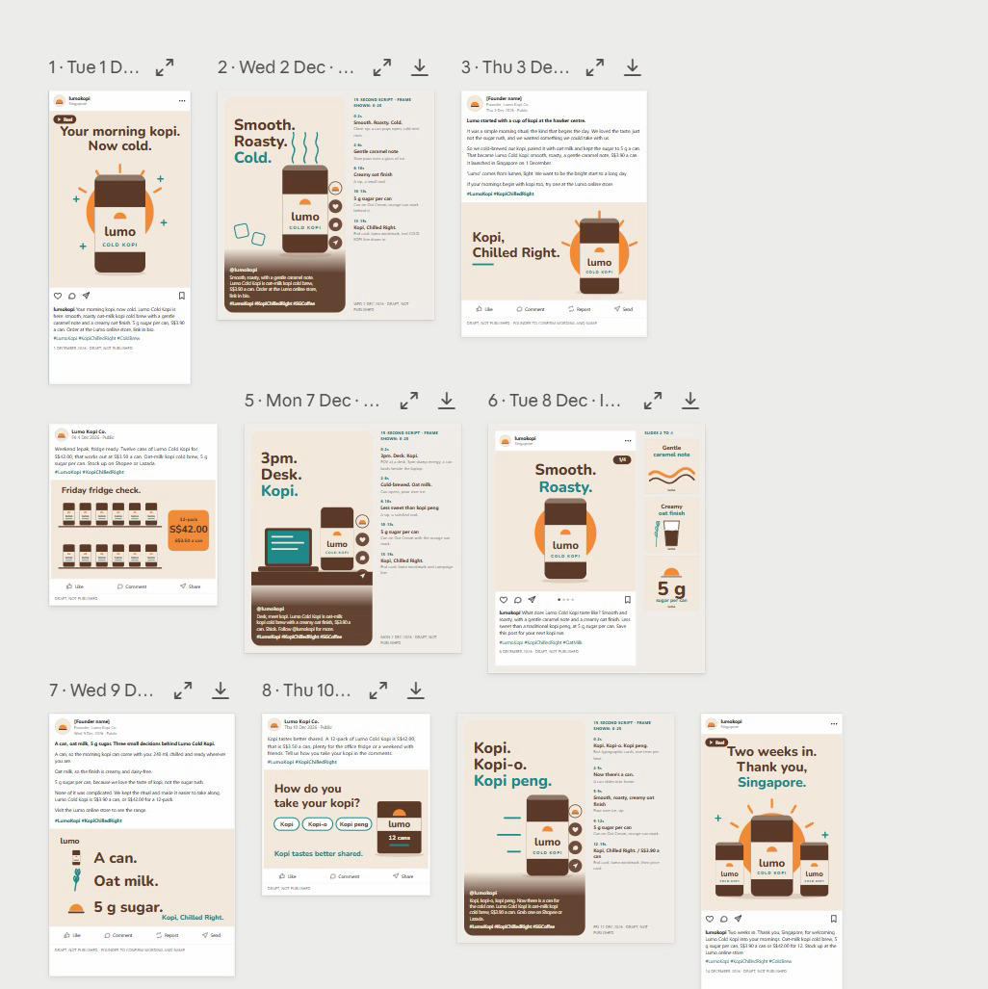
Figure 17 — From the Class: Two Weeks of Posts. The Lab 8 posts laid out by date — every one a draft, not published.
1. One calendar — Dated posts from 1 to 14 December across the four platforms.
2. One voice — The brand-voice skill keeps every hook and caption consistent.
3. Review — Expand or download any post; each is marked DRAFT, NOT PUBLISHED.

The video pipeline
Claude does not edit video by hand — it writes and runs the code that renders it. The work runs in five stages:
1. Script — Five lines, three seconds each — hook, problem, product, proof, call to action.
2. Storyboard — One frame per line: which image, which on-screen text, which motion.
3. Render — Claude writes and runs code that animates your images and text into an MP4.
4. Check — Length, size 1080 × 1920, brand colours, every claim true, end card with the price.
5. Refine — Ask for timing or text changes in plain English and render again.
Video specifications
Spec | Requirement
Format | Vertical 9:16, 1080 × 1920 pixels, MP4 — fits Reels, TikTok and Shorts.
Length | 15 seconds: five scenes of three seconds each.
Text | Large, high-contrast captions — most people watch with the sound off.
Brand | Lumo colours and logo; the end card shows the price and the campaign hashtag.
Assets | Only the supplied product images — never a real person's likeness or a stock logo.
Fallback | No video tools in the session? Claude builds an animated HTML version to screen-record.

Lab 9 — Produce a 15-Second Launch Video
Objective: By the end of this lab you can script, storyboard and render a vertical launch video from supplied brand assets.
Scenario: The TikTok and Instagram posts need a launch video. You give the project the supplied product images and logo; one thread writes a five-scene script and storyboard with lumo-brand-voice, another writes and runs the code that animates the images and captions into a 15-second, 1080 × 1920 MP4. You check it frame by frame and ask for changes in plain English.
You will build: lumo-launch-15s.mp4 (1080 × 1920, 15 seconds), with its script and storyboard.
Tools: Claude Projects, threads, code execution.
In the project
Part | In this lab
Instructions — HOW | Uses: brand voice for the script; nothing is published.
Context — WHAT | Uses: the brand kit, for the tagline, price and call to action.
Folder — WHERE | Adds: attach the video assets; the script, storyboard and lumo-launch-15s.mp4 are saved.
Scheduled — WHEN | Not used — runs when you send the prompt.

Lab files
- Prompt PDF: labs-threads/lab-09-launch-video/lab-09-launch-video.pdf
- labs-threads/lab-09-launch-video/data/video-assets/lumo-can.png
- labs-threads/lab-09-launch-video/data/video-assets/lumo-12pack.png
- labs-threads/lab-09-launch-video/data/video-assets/lumo-logo.png
- labs-threads/lab-09-launch-video/data/video-assets/scene-hawker.png
- labs-threads/lab-09-launch-video/data/video-assets/scene-office.png
Step-by-step
1. Open the Lab 09 data/video-assets folder and look at the five images.
Why: These are the only images the video may use. Supplying assets is how you keep likenesses and logos safe.
2. In the project, attach the folder and send the lab prompt.
Why: Two threads, but not in parallel this time: the render thread waits for the script. The lead agent manages that order.
PROMPT — copy into Claude
Make a 15-second vertical launch video for Lumo Cold Kopi, using
only the five images in the attached video-assets folder.

Use two threads:
Thread 1 - SCRIPT: with lumo-brand-voice, write five scenes of
three seconds each: hook, problem, product, proof, call to action.
For each scene give the image, the on-screen text (max 6 words)
and the motion. Save it as lumo-video-storyboard.md.
Thread 2 - RENDER: when the storyboard is ready, write and run
code that renders it to lumo-launch-15s.mp4: 1080 x 1920, 30 fps,
exactly 15 seconds, large high-contrast captions in the Lumo
colours, a gentle zoom on each image, and an end card with the
logo, "From S$3.90" and #KopiChilledRight.

If you cannot render video in this session, build the same thing
as an animated HTML page at 1080 x 1920 and tell me, so I can
screen-record it. Report the file's duration and size when done.

Note: Attach the whole video-assets folder. Use only the supplied images — never a real person's likeness or another brand's logo.
3. Read the storyboard when Thread 1 finishes.
Why: Five scenes, three seconds each, captions of six words or fewer, and no health claims — the brand-voice skill applies to scripts too.
4. When the video arrives, check the reported duration and size.
Why: Exactly 15 seconds and 1080 × 1920. A wrong size is the most common reason a platform crops your captions.
5. Play it through, then scrub it frame by frame.
Why: Check every caption is readable with the sound off and the end card shows the logo, From S$3.90 and #KopiChilledRight.
6. Ask for one change, for example: Hold the end card for one second longer and shorten scene 2.
Why: The video is code, so a change is a re-render, not a re-edit. Check the length is still 15 seconds afterwards.
7. If Claude built the HTML fallback instead, open it full screen and screen-record 15 seconds.
Why: Same storyboard, different renderer. The checks stay the same.
Check
You are done when: lumo-launch-15s.mp4 is 1080 × 1920, 30 fps and 15 seconds long, uses only the supplied images, shows five scenes with captions of six words or fewer in the Lumo colours, and ends on a card with the logo, "From S$3.90" and #KopiChilledRight. lumo-video-storyboard.md sits beside it and matches what plays. No scene makes a health claim.

Scheduled tasks
A scheduled task has six parts. Write each one down before you schedule anything:
Part | What to decide
Prompt | Exactly what to do each run — written like a lab prompt, with the checks included.
Frequency | Daily, weekdays, weekly or monthly.
Time | When it runs, in your time zone — for example, weekdays at 9:00am.
Where it runs | Inside the project, so it reads the same goal, context, memory and skills.
Output | Where the result goes — an email draft, a file in Drive, a note in the project.
Approval | The step a human still takes — the task drafts, you publish.

Examples for the launch
Schedule | Task
Daily post, weekdays 9:00am | Take today's row from the social calendar, polish it with lumo-brand-voice and email it to me for approval.
Weekly report, Mondays 8:00am | Summarise last week's posts from the social calendar and anything new in the Lumo Launch Drive folder in five bullet points.
Monthly scan, 1st at 10:00am | Check the six competitors for new products or price changes and update the research brief.

A local task needs the app open. To keep tasks running with the laptop closed, give the project a cloud environment in Project settings → Environment.
Responsible marketing with Claude
Speed is only useful if what goes out is true and fair. Keep these rules on every job:
Rule | In practice
Claims you can prove | “5 g sugar” is on the label. “Healthy” is a claim Lumo cannot substantiate — never use it.
Consent for email | Email only people who opted in. Lab emails go to yourself, never to real customers.
No real likenesses | Do not generate a real person, influencer or competitor logo into an ad.
Disclose partnerships | Influencer posts are labelled as paid partnerships.
A human publishes | Claude drafts and schedules drafts; a person approves every public post.
Keep the source | Keep the research files, so every number in a post can be traced back.

Lab 10 — Schedule the Weekly Report and Review the Project
Objective: By the end of this lab you can schedule a weekly report beside the daily post, edit project memory and review thread usage.
Scenario: Lab 8 scheduled the daily post. The launch also needs a report every Monday, and nobody should have to remember it. You schedule it inside the project beside the daily post, then do the housekeeping a real project needs: correct its memory when a plan changes, and read the usage of the lead agent and each thread to see what parallel work costs.
You will build: A weekly-report scheduled task beside Lab 8's daily post, an updated project memory and a usage review.
Tools: Claude Projects, scheduled tasks, memory, Gmail connector.
In the project
Part | In this lab
Instructions — HOW | Reviews: which instructions are now out of date.
Context — WHAT | Reviews: which context files the launch-date change affects.
Folder — WHERE | Updates: project memory records the 8 December Singapore launch.
Scheduled — WHEN | NEW: Weekly launch report, Mondays at 8:00am — beside Lab 8's daily post.

Lab files
- Prompt PDF: labs-threads/lab-10-schedule-and-review/lab-10-schedule-and-review.pdf
This lab has no data folder — it works from what the project already holds.
Step-by-step
This lab has three blocks. Block 1 schedules the weekly report. Block 2 changes the launch plan through project memory. Block 3 asks the project to review itself.
Note: Scheduled tasks that run locally need the desktop app open. To run them with your laptop closed, add a cloud environment in Project settings → Environment.
1. Send Block 1 with your own email address in place of <YOUR EMAIL>, and read the task before it is saved.
Why: Mondays at 8:00am. The task runs inside the project, so it inherits the goal, instructions, context and memory — the prompt stays short.
Block 1 — SCHEDULE
Send this to the lead agent:
PROMPT — copy into Claude
Schedule a recurring task in this project: "Weekly launch
report", Mondays at 8:00am. Summarise last week's posts from
social-calendar.csv and anything new in the Lumo Launch Drive
folder in five bullet points, and email the summary to
<YOUR EMAIL>. Draft only - do not send anything else.

Show me the task before you save it.

Open Scheduled and confirm both tasks are listed: Today's Lumo post from Lab 8, and Weekly launch report.
2. Open Scheduled in the project and confirm both tasks are listed.
Why: Today's Lumo post from Lab 8 and the weekly report: two timetables, one project. This is where you would add a monthly competitor scan next.
3. Send Block 2, then read the list of things that depend on the date.
Why: Expect the calendar, Task 1, the deck's title slide and timeline, and the brief. Memory is how one fact reaches every thread.
4. Open Project settings → Memory and find the new launch-date entry. Edit it if the wording is wrong.
Why: The project writes memory, but you own it. Delete anything you would not want every future thread to believe.
Block 2 — MEMORY
Send this to the lead agent:
PROMPT — copy into Claude
Remember this for the project: the Singapore launch has moved
from 1 December to 8 December 2026. Kuala Lumpur is unchanged.
Tell me everything in the project that depends on the launch
date - posts, tasks, the deck, the brief - and propose the
changes. Do not make them yet.

Open Project settings → Memory, find the new entry, and correct the wording if needed.
5. Send Block 3 at the end of the lab.
Why: A project that can list its own threads and outputs is one a colleague can pick up tomorrow.
6. Open Project settings → Usage and read the lead agent's and each thread's tokens.
Why: Parallel threads finish faster but use more in total. Compare the research threads from Lab 2 with the single-thread labs.
Block 3 — REVIEW
Send this at the end of the lab:
PROMPT — copy into Claude
Review this project for me: list the threads you started today,
what each produced, and where each output is saved. Then tell
me which context files, instructions or memory entries are now
out of date.

Compare its list with Project settings → Usage, which shows the tokens used by the lead agent and each thread.
Check
You are done when: Two tasks are listed under Scheduled — Today's Lumo post from Lab 8 on weekdays at 9:00am and Weekly launch report on Mondays at 8:00am — both drafting and emailing only, with nothing published. Project memory records the 8 December Singapore launch, and the lead agent listed what depends on it. Project settings → Usage shows tokens for the lead agent and for each thread you started today.

Wrap-Up
Across ten labs you took one product launch from an empty project to a researched, branded and scheduled campaign.
What you built
- The Lumo Cold Kopi Launch project, with a goal, instructions, context and memory.
- A market research brief built from four parallel threads, with conflicts flagged.
- A Market Insights Live Artefact dashboard, saved and downloaded.
- Google Drive and Gmail connected, with an approved summary sent to yourself.
- A launch deck in Slides and a campaign brief in Docs.
- A lumo-brand-voice Agent Skill and the Marketing plugin.
- Two weeks of social posts across four platforms, drafted in parallel threads.
- A 15-second vertical launch video.
- Scheduled tasks that draft the daily post and the weekly report for your approval.
The habit to keep
- Give long-running work a project with a clear goal, not a string of chats.
- Split big jobs into threads, one subject each, and let the lead agent merge them.
- Check every figure and claim against the source before anything goes out.
- Write a routine down once as a skill instead of retyping it every time.
- Schedule the drafting; keep the publishing click for yourself.
Next steps
- Start one real Project — Give your next campaign a project with a goal, instructions and context.
- Split one job into threads — Next time you research competitors, give each one its own thread.
- Capture your brand voice — Turn your real brand guide into a skill your whole team shares.
- Analyse one dataset — Attach a real export, define your terms, and check the code and the totals.
- Schedule one routine — Pick the post or report you produce every week and schedule the draft.
- Browse Discover — See which plugins already exist before you write a skill someone has packaged.

Glossary
Term | Meaning
Agent Skill | A folder containing a SKILL.md of instructions that Claude loads on demand when the task matches its description.
Artefact | A self-contained output Claude builds — a document, dashboard or tool — shown beside the chat rather than inside it.
Claude Project | A workspace for one long-running goal, with its own instructions, context, memory, threads and scheduled tasks.
Connector | An integration that lets Claude reach an outside service such as Google Drive, Gmail or Calendar.
Context | Reference material a project reads but never edits — files, a folder, a Google Drive folder or a GitHub repository.
Effort | How hard a model thinks before it answers. Higher effort is more thorough and uses more of your limit.
Instructions | Standing rules you write once that every session in a project follows — how Claude must behave.
Lead agent | The project's coordinator: it plans each job, starts threads and merges their results. Also called the coordinator.
Live Artefact | An artefact that persists in your workspace, keeps its state, and can refresh its data when reopened.
MCP | Model Context Protocol — the open standard connectors use to expose tools and data to Claude.
Memory | Facts and decisions a project writes down as it works, readable by every thread and editable by you.
Mod | A change to Claude's own interface or behaviour, such as a side panel, status line, slash command or hook.
Plugin | A packaged bundle of skills, tools, agents and hooks, installed in one step.
Scheduled task | A prompt a project runs automatically on a timetable.
Session | One conversation with Claude, with its own context window. A project holds many sessions.
SKILL.md | The Markdown file at the heart of an Agent Skill: name, description and instructions.
Code execution | Claude's built-in tool for writing and running code on your files — how it analyses data, draws charts and builds files.
Tool | One action Claude can take — search, read, run code, create a file, send. Built in, or added by a connector.
Tool call | One use of a tool, shown as a step in Claude's reply with its input and its result.
Thread | One parallel worker inside a project, started by the lead agent with a focused brief and its own context window.

